THAKUR RAM SINGH SMRITI NYAS, HIMACHAL PRADESH
Report on Humanitarian Relief for Himachal Pradesh Flood and Landslide Affected Families
Detailed Draft Report | July-September 2025 Interventions
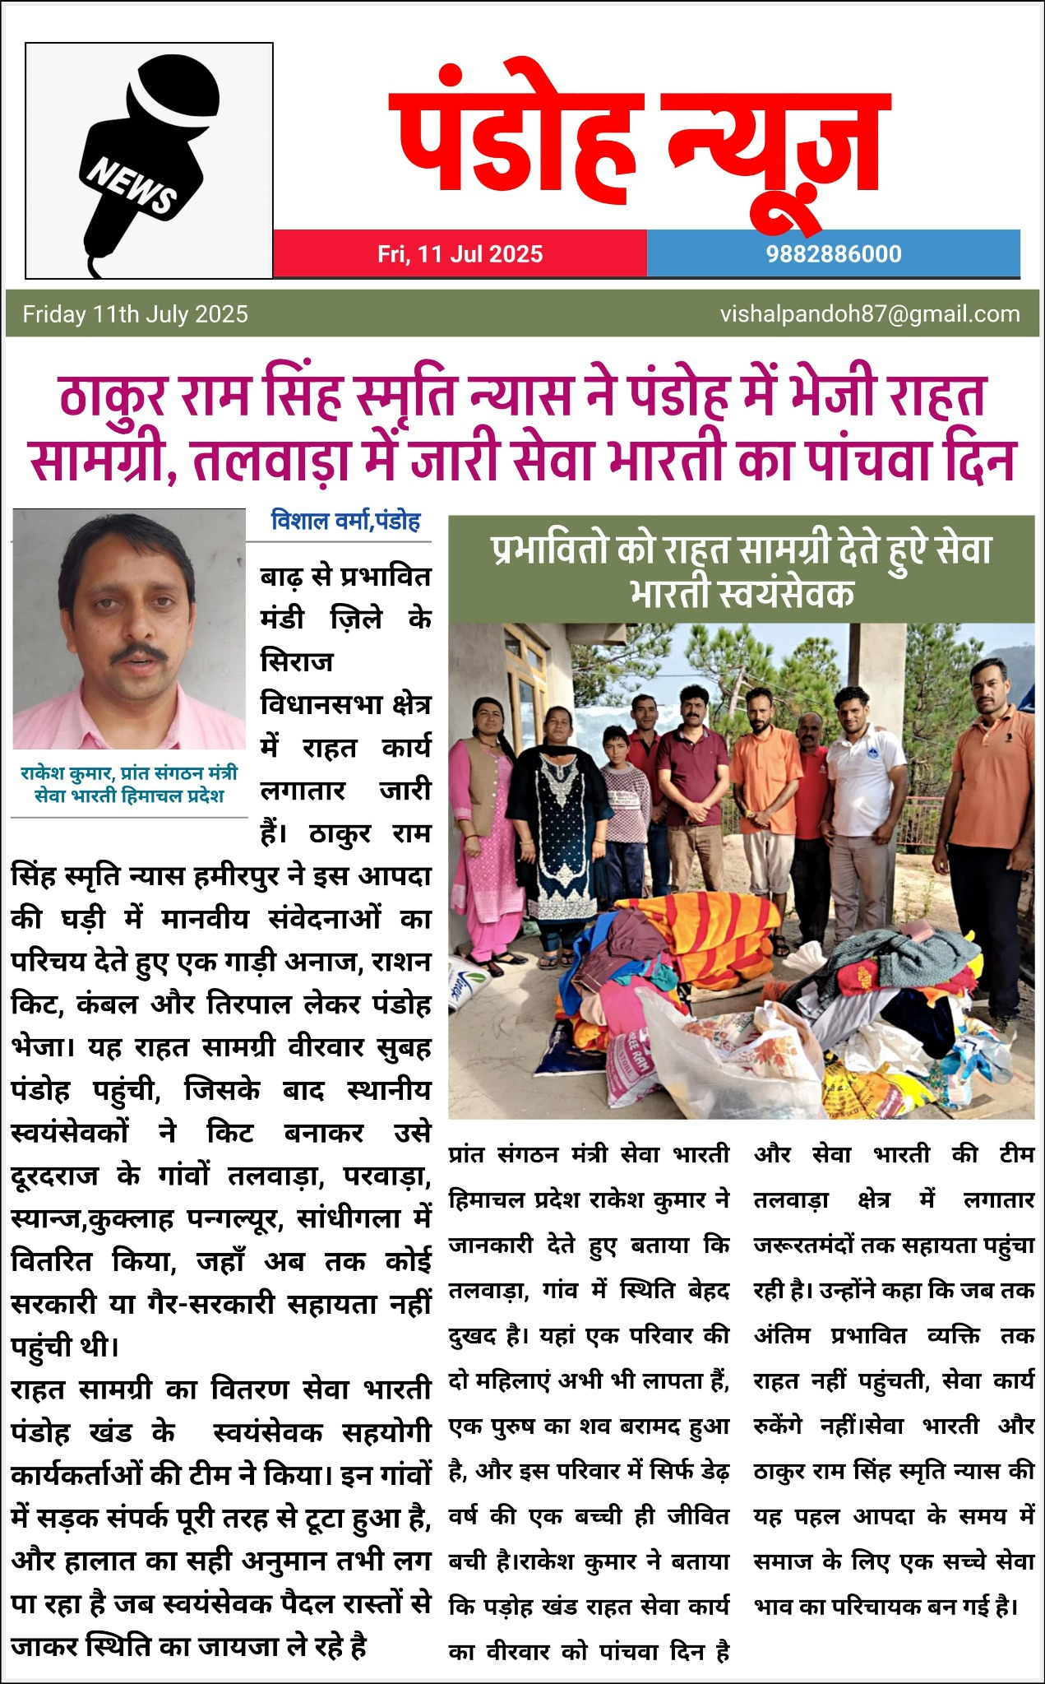
Figure 1. Newspaper clipping documenting relief material and volunteer coordination in Pandoh/Talwara area, July 2025.
Prepared as a draft evidence report for documentation, donor communication, statutory record, and future disaster-response planning.

Executive Summary
This report documents the humanitarian relief response undertaken by Thakur Ram Singh Smriti Nyas, Himachal Pradesh, during the 2025 monsoon disaster period. The uploaded newspaper clippings and audited financial statements show that the Trust combined immediate in-kind relief with targeted monetary assistance to families affected by floods, cloudbursts, landslides and associated disruptions. The response was not merely a one-time charitable act; it was an organized process combining public information, local volunteer networks, ground verification, and cheque-based disbursement to affected households and committees. The relief effort is best understood as a bridge between immediate survival needs and early recovery needs, especially for families whose housing, livelihoods, food security, transport connectivity, and psychological security were shaken by the disaster.
The documentary evidence supplied for this report records four major relief streams: first, dispatch of relief material to Pandoh and service support in the Talwara belt; second, financial assistance of approximately Rs 10.50 lakh to 42 disaster-affected families in the Chamba region; third, assistance of Rs 1.30 lakh to 11 landslide-affected families in the Tissa/Churah region; and fourth, a cheque of Rs 1.00 lakh to an affected-family committee in the Rupnagar/Paonta area. The report treats these figures as documented interventions based on the supplied clippings and notes that the in-kind Pandoh/Talwara relief had no monetary valuation stated in the uploaded clipping.
The broader disaster environment was severe. Himachal Pradesh faced repeated episodes of intense rainfall, flash floods, cloudbursts and landslides during the 2025 monsoon. Public sources cited in this report record rising human losses during the season, official deployment of central assessment teams, availability of a formal State Post-Disaster Needs Assessment framework, and significant economic damage estimates. In this context, the Trust’s local, fast and verified action helped fill a gap between state-level assistance and household-level distress. The Trust’s intervention model was characterized by proximity, credibility, volunteer verification, and a focus on families whose needs were immediate and visible on the ground.
The report also reviews four years of uploaded audited accounts. Those accounts show a trust with a significant asset base, recurring donation income, and a recorded Aapda Rahat Kosh during 2023-24. Donation income decreased from Rs 48.10 lakh in 2021-22 to Rs 9.37 lakh in 2024-25, while annual expenditure continued at a substantial level. This pattern makes it important for the Trust to build a more structured disaster fund, adopt formal beneficiary-selection documentation, maintain follow-up evidence, and use impact reporting to strengthen donor confidence.
The report proposes a scientific methodology for future relief assessment: a two-stage process beginning with government situation reports and PDNA-style sector information, followed by ground visits, household vulnerability scoring, triangulation with Panchayat and volunteer inputs, disbursement through traceable instruments, and follow-up verification. The proposed model uses risk-priority scoring, household vulnerability indexing, damage-loss-need separation, and a clear evidence trail. The goal is not to make relief bureaucratic; the goal is to make compassion measurable, fair, transparent and repeatable.

Introduction
Disaster-relief reports often become important long after the first emergency has passed. In the early days after a flood, the community remembers the immediate actions: who arrived first, who brought food, who helped identify the families that had no safe shelter, and who ensured that help reached without delay. Months later, however, the same events must be documented in a more systematic manner so that donors, trustees, government authorities, community members and future volunteers can understand what happened, why certain areas were prioritized, how funds were used, and what lessons can be drawn for the next emergency. This document has been prepared with that purpose.
The 2025 monsoon disaster in Himachal Pradesh was not a single isolated event. The uploaded clippings and public sources together show a pattern of repeated rainfall-triggered emergencies: cloudbursts, landslides, road disruptions, flash floods, damage to houses, loss of household articles, and displacement of families. In mountainous regions, such events create a cascading crisis. A landslide may destroy a house, but it also blocks a road. A blocked road delays medical care, the supply of food, and the arrival of officials. Flooded or washed-away paths make schooling, work, animal care and social support difficult. Thus, even a small cash grant or a ration kit can have a wider meaning when it reaches a family at the correct time.
Thakur Ram Singh Smriti Nyas appears from the uploaded record to have acted through a combination of institutional leadership and local volunteer networks. The clippings mention office bearers, social workers, local representatives, and Seva Bharati/Rashtriya Swayamsevak Sangh workers involved in the identification, physical visit, assistance and cheque-handover process. This is important because disaster relief in hill terrain depends heavily on local knowledge. Administrative records can identify macro-level damage, but community volunteers often identify household-level distress: a family living with relatives, a widow who lost essential belongings, a household cut off from road access, or families whose immediate needs are not visible in aggregate data.
The report is based on three layers of material. The first layer consists of the uploaded newspaper clippings documenting the Trust’s work and the relief interventions. The second layer consists of the uploaded audited financial statements for 2021-22, 2022-23, 2023-24 and 2024-25, which provide institutional financial context. The third layer consists of public sources on the 2025 Himachal monsoon disaster, including official pages and news reports. Each source type has a different purpose: newspaper clippings establish contemporaneous community evidence; audited accounts establish institutional financial capacity and trend; public sources establish the severity and macroeconomic context of the disaster.
The immediate audience for this draft report includes trustees, donors, social workers, auditors, district-level stakeholders and prospective supporters. A secondary audience includes future volunteers who may need to understand how to conduct field verification and document relief work. Therefore, the report uses both narrative and analytical sections. It does not merely say that assistance was given; it also explains how such assistance can be prioritized, measured, monitored and scaled.
The report’s central argument is that the Trust’s intervention was valuable because it connected three things that are often separated in disaster response: compassion, evidence and delivery. Compassion ensured urgency. Evidence ensured that help was not random. Delivery ensured that assistance reached households and committees through visible and accountable mechanisms such as cheques and organized material distribution. When these three elements come together, a small or medium-sized community institution can have a large effect on household dignity and recovery confidence.

About the Trust
Thakur Ram Singh Smriti Nyas, Himachal Pradesh, is reflected in the uploaded accounts as a continuing social institution with a formal balance sheet, recurring donation income, fixed assets, current assets, and activity expenditure. The name of the Trust appears consistently in the audited statements from 2021-22 to 2024-25. The statements record charitable and social expenditure heads such as charity to needy, activity expenses, blood donation expenses, books for students, awareness camps, honorarium, kitchen expenses, repairs and maintenance, and other institutional expenses. This financial evidence indicates that the Trust is not an ad hoc relief group but an established body with regular charitable and social operations.
The Trust’s audited statements show that it maintains a capital fund and assets, including a building account and equipment-related assets. This is significant for relief work because institutional continuity allows a trust to act quickly when emergencies arise. Organizations without a standing structure often have to create systems during a crisis; organizations with existing accounts, trustees, local workers and community recognition can mobilize more quickly.
The 2023-24 financial statements record a specific Aapda Rahat Kosh, or disaster relief fund, in the capital account and receipts/payments statements. The presence of this fund head is important because it shows a conscious financial category for disaster-related giving. The uploaded 2023-24 balance sheet records Aapda Rahat Kosh as part of the capital account, while the receipts and payments statement records receipts and payments under this head. This creates a foundation for a more formal disaster-response reserve that can be strengthened in future years.
The Trust’s public image, based on the uploaded clippings, is linked not only to financial donation but also to personal engagement. The clippings show office bearers and volunteers physically meeting affected families, distributing cheques, visiting affected areas, and coordinating with local representatives. This physical presence is a form of accountability. In the context of disaster relief, it matters because affected families often feel unseen. A visit by a recognized institution validates their suffering and helps rebuild social confidence.
The Trust’s values can be summarized as service, memory, community duty and social solidarity. A memorial trust carries a responsibility to convert memory into public good. In this case, the memory of Thakur Ram Singh is expressed through action for disaster-affected households. The report therefore treats the relief work not only as expenditure but as institutional mission fulfillment.
Financial year | Donation income | Interest/other income | Total income | Expenditure | Net result | Total assets
2021-22 | Rs 4,810,243 | Rs 189,876 | Rs 5,000,119 | Rs 2,520,406 | Rs 2,479,714 | Rs 14,505,312
2022-23 | Rs 4,371,440 | Rs 26,007 | Rs 4,397,447 | Not specified in source | Rs -2,791,925 | Rs 13,704,244
2023-24 | Rs 3,632,497 | Rs 36,520 | Rs 3,673,017 | Rs 2,177,714 | Rs 1,495,303 | Rs 16,240,046
2024-25 | Rs 937,301 | Rs 32,410 | Rs 969,711 | Rs 2,116,914 | Rs -1,147,203 | Rs 14,962,343
Table 1. Financial profile extracted from uploaded audited statements. The 2022-23 expenditure figure is not reproduced as a single income/expenditure statement total in the parsed document; net result is taken from the balance sheet line.
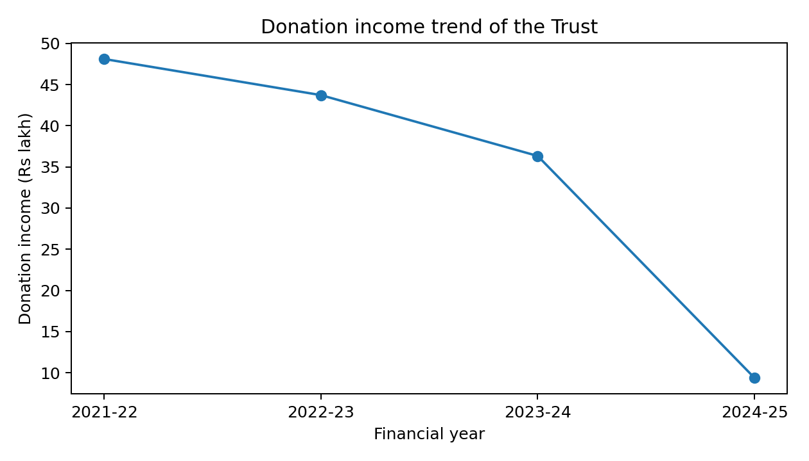
Figure 2. Donation income trend shows a declining donation base by 2024-25, indicating the need for a ring-fenced disaster reserve.
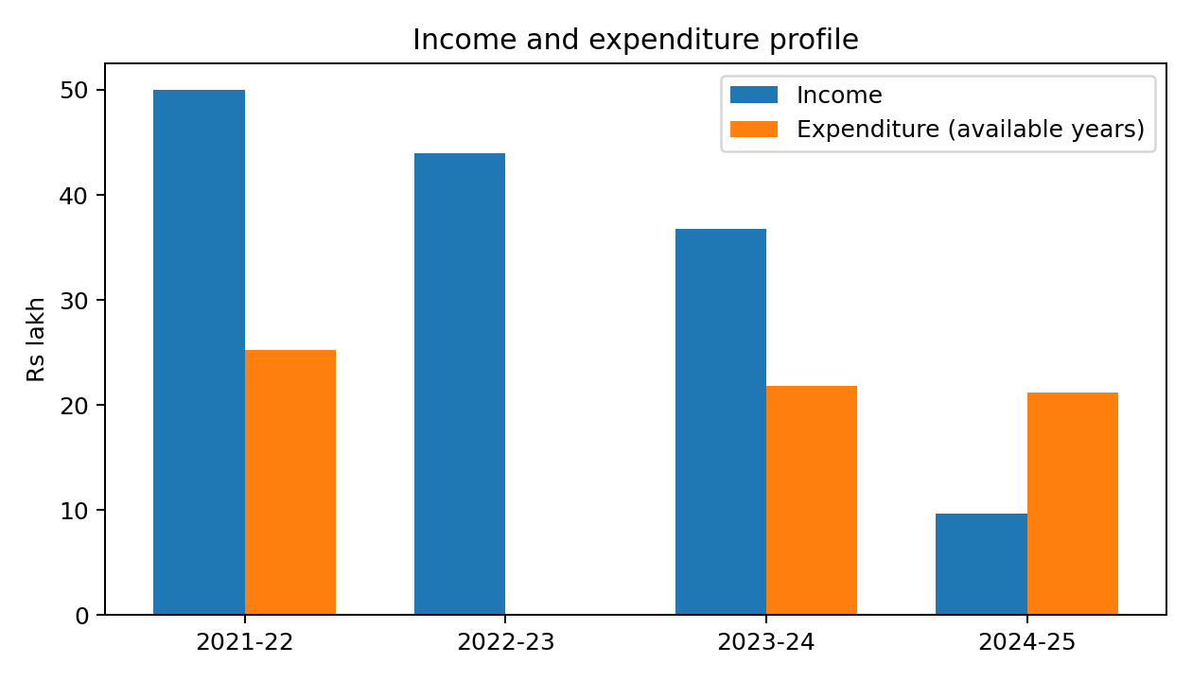
Figure 3. Income and expenditure profile based on uploaded accounts where full expenditure data was available.

Himachal Floods and Landslides: Context
The 2025 Himachal disaster unfolded within the fragile geography of the western Himalaya. The state’s terrain is characterized by steep slopes, young mountains, narrow river valleys, road cuts, dispersed settlements and heavy dependence on slope stability. In such landscapes, extreme rainfall produces multiple hazards at once. Rivers swell, hill slopes fail, boulders and debris enter roads and habitations, and hydrological systems respond quickly because catchments are steep and drainage is rapid. Therefore, the impact of rainfall is not limited to flooded riverbanks; it includes landslides, debris flows, road blockages, collapsing retaining walls, damaged water supply systems and power disruptions.
Public reporting during the 2025 monsoon recorded repeated flash floods, cloudbursts and landslides. News reports citing State Disaster Management Authority information recorded rising deaths through July and August, while government sources documented the deputation of central assessment teams and the presence of NDRF teams for rescue and relief. The Himachal Pradesh State Disaster Management Authority also maintains a 2025 Post Disaster Needs Assessment page, indicating that the disaster was serious enough to require sector-wise recovery assessment and annexures for housing, tourism, forestry, fisheries, public works, Jal Shakti, power, education, anganwadi centres, rural development assets, animal husbandry, agriculture, horticulture and health.
The existence of a PDNA process is important for this Trust report because it provides a scientific frame for interpreting local relief work. A PDNA separates immediate relief from recovery and reconstruction. It looks not only at the damage to physical assets but also at economic losses, human impacts and future recovery needs. The Trust’s work was located at the household-relief and early-recovery end of this continuum. Its relief kits and cheques could not rebuild the whole damaged infrastructure of Himachal Pradesh, but they could reduce the immediate burden on affected families and help them restore basic consumption, dignity and mobility.
Mountain disasters also have a distinct economic character. The direct damage may be a broken house wall, lost bedding, washed-away supplies or damaged road. But the indirect loss includes missed work, reduced tourism income, crop losses, medical costs, transport disruption, school interruption and the cost of temporary accommodation. For poorer households, a relatively modest grant can have a high marginal utility because it allows the family to buy essentials, replace school items, repair a temporary shelter, pay for transport, or meet immediate food needs while waiting for larger official processes.
The Trust’s work, therefore, should be assessed in terms of immediacy, targeting and social value rather than only the absolute size of the donation. A donation of Rs 25,000 to a household that has lost bedding, food stocks and wage continuity may prevent distress borrowing. A ration kit reaching a road-disconnected household may prevent acute food insecurity. A public cheque-handover can also signal community solidarity, which matters in rural disaster contexts where confidence and social trust are part of recovery.

Scale of the Tragedy
The scale of the 2025 tragedy can be viewed through five dimensions: human loss, housing damage, infrastructure disruption, livelihood shock and institutional response. The first dimension, human loss, includes deaths, injuries, missing persons, trauma and family-level insecurity. Public reports during the season recorded a rising death toll, with separate categories for rain-related deaths and road-accident deaths during the hazardous monsoon period. The fact that the numbers changed over time is itself a sign of the evolving nature of the crisis: as rain continued and roads remained unstable, the disaster expanded beyond the first event.
The second dimension is housing and household damage. The uploaded clippings repeatedly refer to affected families rather than only damaged infrastructure. This is important because disaster statistics often aggregate damage, whereas relief work must engage with households. A completely damaged house requires long-term reconstruction, but even a partially damaged house can create immediate needs: tarpaulins, bedding, utensils, dry ration, cooking fuel, medicines, school materials, winter clothing and temporary rent support. The Trust’s relief material and monetary assistance were directed toward this household-level distress.
The third dimension is infrastructure disruption. In Himachal Pradesh, roads are lifelines. A road blocked by a landslide is not merely a transport inconvenience; it interrupts access to hospitals, markets, schools, administrative offices and relief distribution points. It also raises the cost of every household good because supplies must travel longer routes or wait until roads reopen. Public reports in 2025 described damage to roads, bridges, public utilities and services. This means that affected households were not only suffering asset loss but also facing higher transaction costs for recovery.
The fourth dimension is livelihood shock. Affected households may include daily wage workers, small farmers, shopkeepers, drivers, tourism-linked workers, service workers and families dependent on remittances or seasonal labor. Floods and landslides reduce work opportunities at the same time as they increase expenses. Agricultural and horticultural losses can be particularly painful because they affect annual income cycles. When a family loses crops or livestock-related assets, the loss cannot be replaced simply by one month of relief. However, immediate assistance can prevent a slide into debt during the first phase.
The fifth dimension is institutional response. The public record shows that the central government recognized the seriousness of repeated disasters in the state and supported assessment, deployment and relief processes. State-level PDNA documentation also indicates movement toward structured recovery planning. Within this wider ecosystem, community trusts like Thakur Ram Singh Smriti Nyas play a complementary role. They are not substitutes for government relief; they are accelerators and gap-fillers. They can reach specific families, mobilize local credibility, and provide flexible assistance where formal processes may take time.
The evidence from the uploaded clippings suggests that the Trust’s interventions were geographically dispersed: Pandoh/Talwara belt, Chamba/Mugla area, Tissa/Churah region, and another affected-family committee in the Paonta/Rupnagar context. Such dispersion is notable because it suggests a networked response rather than a single ceremonial donation. It also suggests that the Trust relied on local teams to identify pockets of distress.
Dimension | Evidence/indicator | Relief implication
Human loss and trauma | Deaths, injuries and missing persons reported during 2025 monsoon; affected families identified in clippings | Need for dignity-centred, rapid and locally verified assistance
Household damage | Families receiving direct assistance; material relief containing ration, blankets, rice, clothes and essentials | Need for immediate consumption support and replacement of essential goods
Infrastructure disruption | Roads, bridges and public utilities affected in public reports | Need for decentralized delivery and volunteer-based access
Livelihood shock | Loss of work days, agriculture/horticulture losses and transport barriers | Need for cash/cheque assistance to reduce distress borrowing
Institutional response | PDNA page, central teams, NDRF deployment and public relief mechanisms | Need for community institutions to complement government systems
Table 2. Disaster scale translated into relief implications for the Trust.

Impact of the Tragedy
The impact of a disaster should not be measured only by the visible force of water or the number of damaged buildings. For a household, the disaster begins when normal life becomes impossible. The first impact is physical insecurity. A family that sees land slide near its home, water enter the settlement, or road access collapse experiences fear and uncertainty. Even if no family member is injured, the sense of safety is shaken. In hill communities, where homes are often close to slopes and roads, the fear of a second event can continue for weeks.
The second impact is economic stress. Households affected by floods and landslides must spend at the very moment when income is disrupted. They may need to purchase food, clothing, bedding, medicines, tools, school items, transport, temporary accommodation or repair material. A daily wage worker loses wages when roads are blocked. A shopkeeper loses customers when the market is inaccessible. A farmer loses income when fields, orchards, irrigation channels or access paths are damaged. Therefore, the economic impact is a combination of asset loss and income interruption.
The third impact is social vulnerability. Widows, elderly persons, persons with disabilities, children, small farmers, tenants and landless workers are often less able to recover without external support. A uniform relief package may not fit all households. Some families need food; others need cash for rent; others need medicine or transport. The Trust’s decision to combine material relief and cheque assistance is therefore appropriate because different households require different types of support.
The fourth impact is educational disruption. When roads are blocked or homes are damaged, students may lose books, uniforms, study time and examination preparation. The Trust’s audited accounts show previous expenditure under educational and student-related heads, which indicates institutional awareness of education as a social priority. Future flood-relief programmes can explicitly include school kits for children in affected families.
The fifth impact is psychological distress. Disaster-affected families frequently experience anxiety, sleep disturbance, loss of confidence and uncertainty about the future. Community visits by trusted social workers help reduce isolation. The uploaded clippings repeatedly show public and personal engagement with affected families, which is valuable beyond the cheque amount. A cheque delivered with respect, conversation and recognition can restore dignity in a way that anonymous relief often cannot.
The sixth impact is on local governance and community cohesion. Disasters test whether communities can act collectively. The clippings show the presence of local leaders, former Panchayat representatives, social workers and volunteers. This indicates that relief work strengthened the relationship between formal community leadership and voluntary service networks. Such networks are crucial in future disasters because they can identify vulnerable families faster than external agencies.

Methodology Adopted by the Trust for Assessment and Donation
The user has indicated that the Trust followed a sequence beginning with government reports and followed by ground visits supported by photographs. This is a sound approach because it combines macro-level reliability with micro-level verification. Government reports provide a first map of affected areas, official incident categories, and broad damage estimates. Ground visits provide the human detail that official tables cannot capture. Together, they reduce two risks: the risk of missing genuine families and the risk of distributing assistance without verification.
A scientific relief methodology should distinguish between hazard, exposure, vulnerability and need. Hazard refers to the event: flood, landslide, cloudburst, road collapse or debris flow. Exposure refers to the people and assets located in the affected area. Vulnerability refers to the household’s ability to absorb and recover from the shock. Need refers to the practical gap that relief can address. For example, two families may live in the same affected village, but one may have savings and relatives nearby while another may be elderly, poor and without alternate shelter. The second household may require higher priority even if the hazard is the same.
The recommended Trust methodology has six steps. Step one is desk review of government situation reports, State Disaster Management Authority bulletins, Panchayat records, and media alerts. Step two is shortlisting affected pockets according to severity, access difficulty and number of vulnerable households. Step three is ground visit by a small team including a Trust representative, local volunteer and community contact. Step four is household verification using a structured form that records family composition, damage type, income disruption, immediate needs and available support. Step five is prioritization and approval by a relief committee. Step six is transparent disbursement through cheque or documented material distribution, followed by photographs and acknowledgment.
The methodology should adopt a Household Vulnerability Index. A simple version can use five scored components: shelter damage, livelihood disruption, dependency ratio, access disruption, and availability of alternate support. Each component can be scored from 0 to 5. Weights can then be assigned according to importance. For instance, shelter damage may receive 30 percent, livelihood disruption 25 percent, dependency ratio 20 percent, access disruption 15 percent and alternate support gap 10 percent. The resulting score is not meant to replace compassion; it is meant to discipline compassion so that support is fair and explainable.
The methodology should also use a Risk Priority Score: RPS = Hazard Severity x Exposure x Vulnerability x Access Constraint. Each component can be scored from 1 to 5. A high score indicates that a location should be visited urgently. This model is useful where the Trust has limited funds and many possible affected areas. It helps the Trust justify why one village was visited first and another later.
Photographic evidence should be organized as a field evidence register. Each photograph should have a date, location, subject, team member, and purpose. A photograph of a damaged house, a road blockage, a cheque handover or relief material distribution should be linked to the beneficiary list. This creates transparency for donors and auditors. However, dignity and privacy must be protected. Photographs should avoid unnecessarily exposing grief, injury or private household conditions unless consent is obtained.
The Trust should maintain separate forms for area assessment, household assessment, donation approval, cheque handover, in-kind material issue and follow-up. A simple digital folder system can be created for each intervention: 01-government reports, 02-field photographs, 03-beneficiary list, 04-approval note, 05-payment proof, 06-media coverage, 07-follow-up. This will make future reporting easier and more credible.
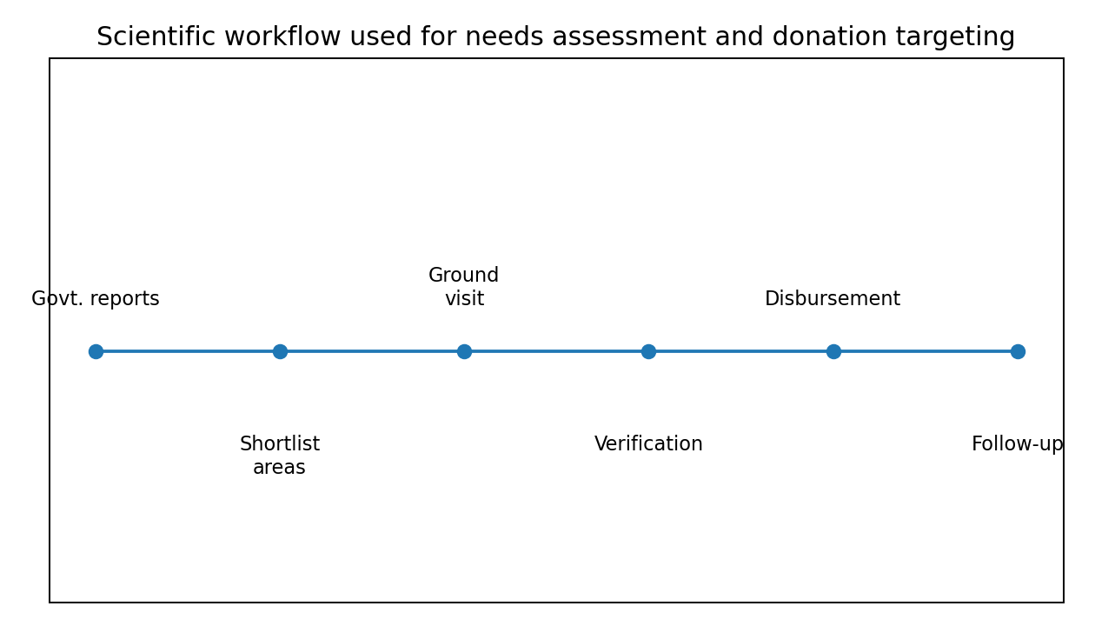
Figure 4. Suggested evidence-based workflow for future Trust disaster relief operations.
Variable | Score range | Meaning | Suggested weight
Shelter damage (S) | 0-5 | Degree of house/room damage, loss of bedding, utensils and safe sleeping space | 30%
Livelihood disruption (L) | 0-5 | Loss of work days, crop/horticulture damage, shop closure, transport disruption | 25%
Dependency ratio (D) | 0-5 | Children, elderly, disabled persons, single women, chronic illness in household | 20%
Connectivity/access (C) | 0-5 | Road blockage, distance to market/health centre, isolation | 15%
Alternate support gap (A) | 0-5 | Whether family lacks savings, relatives, insurance or official relief access | 10%
Table 3. Proposed Household Vulnerability Index for future beneficiary prioritization.
Proposed formula: HVI = (0.30 x S) + (0.25 x L) + (0.20 x D) + (0.15 x C) + (0.10 x A). Households with higher HVI should be prioritized for larger or faster assistance, subject to field verification and committee approval.
Proposed formula: RPS = Hazard Severity x Exposure x Vulnerability x Access Constraint. This can be used for deciding which village or pocket should be visited first when multiple affected areas are reported simultaneously.

Donation Amounts and Handover of Cheques
The uploaded clippings document both material assistance and monetary assistance. The monetary assistance was visibly linked to cheque handovers and public acknowledgment, which improves transparency. The in-kind relief was linked to essential household goods and was particularly relevant for cut-off areas where market access and mobility were disrupted.
Intervention | Documented amount | Beneficiary scale | Mode | Evidence basis
Chamba/Mugla affected families | Rs 10,50,000 | 42 families | Cheques/financial assistance | Uploaded Hindi newspaper clippings showing cheque distribution to disaster-affected families
Hamirpur,sujanpur,chabutra | Rs 1,30,000 | 11 families | Financial assistance | Dainik Savera clipping documenting help to landslide victims
Paonta/Rupnagar affected-family committee | Rs 1,00,000 | Committee/families | Cheque assistance | Uploaded clipping reporting cheque of Rs 1 lakh to disaster-affected family committee
Pandoh/Talwara relief material | Value not stated | Affected families in isolated/affected villages | Ration, blankets, rice, clothes, essentials | Pandhoh Srijan clipping dated July 2025 documenting material relief and field service
Table 4. Documented relief interventions from uploaded newspaper clippings.
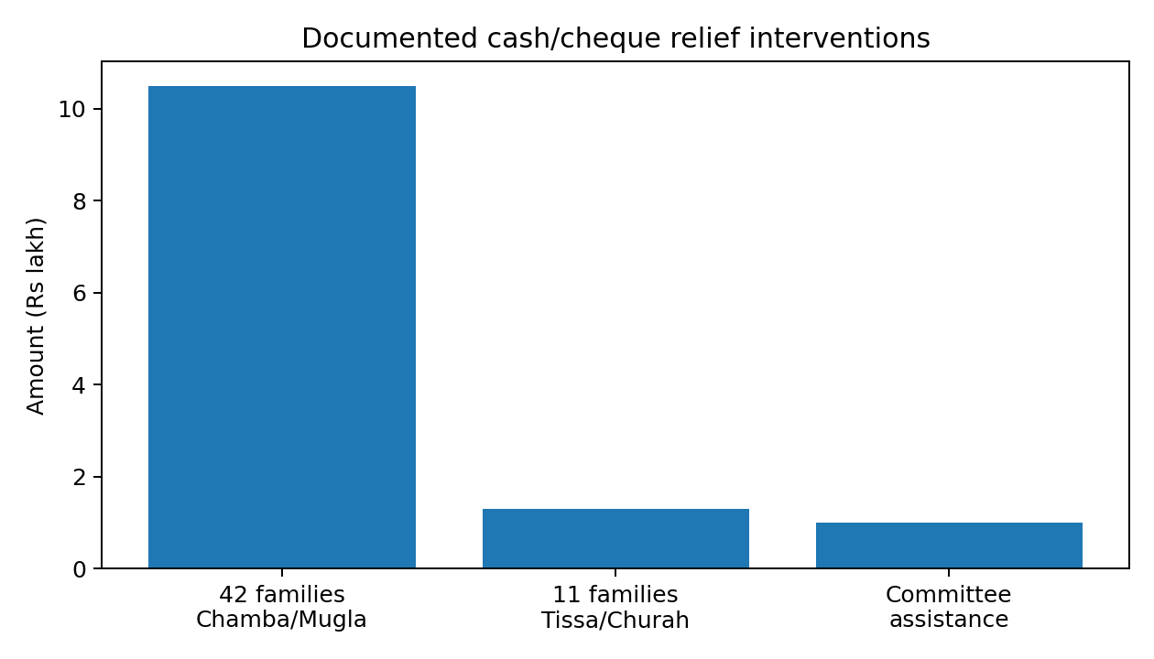
Figure 5. Documented cash/cheque interventions. The value of in-kind relief material is not included because the clipping does not state a monetary valuation.
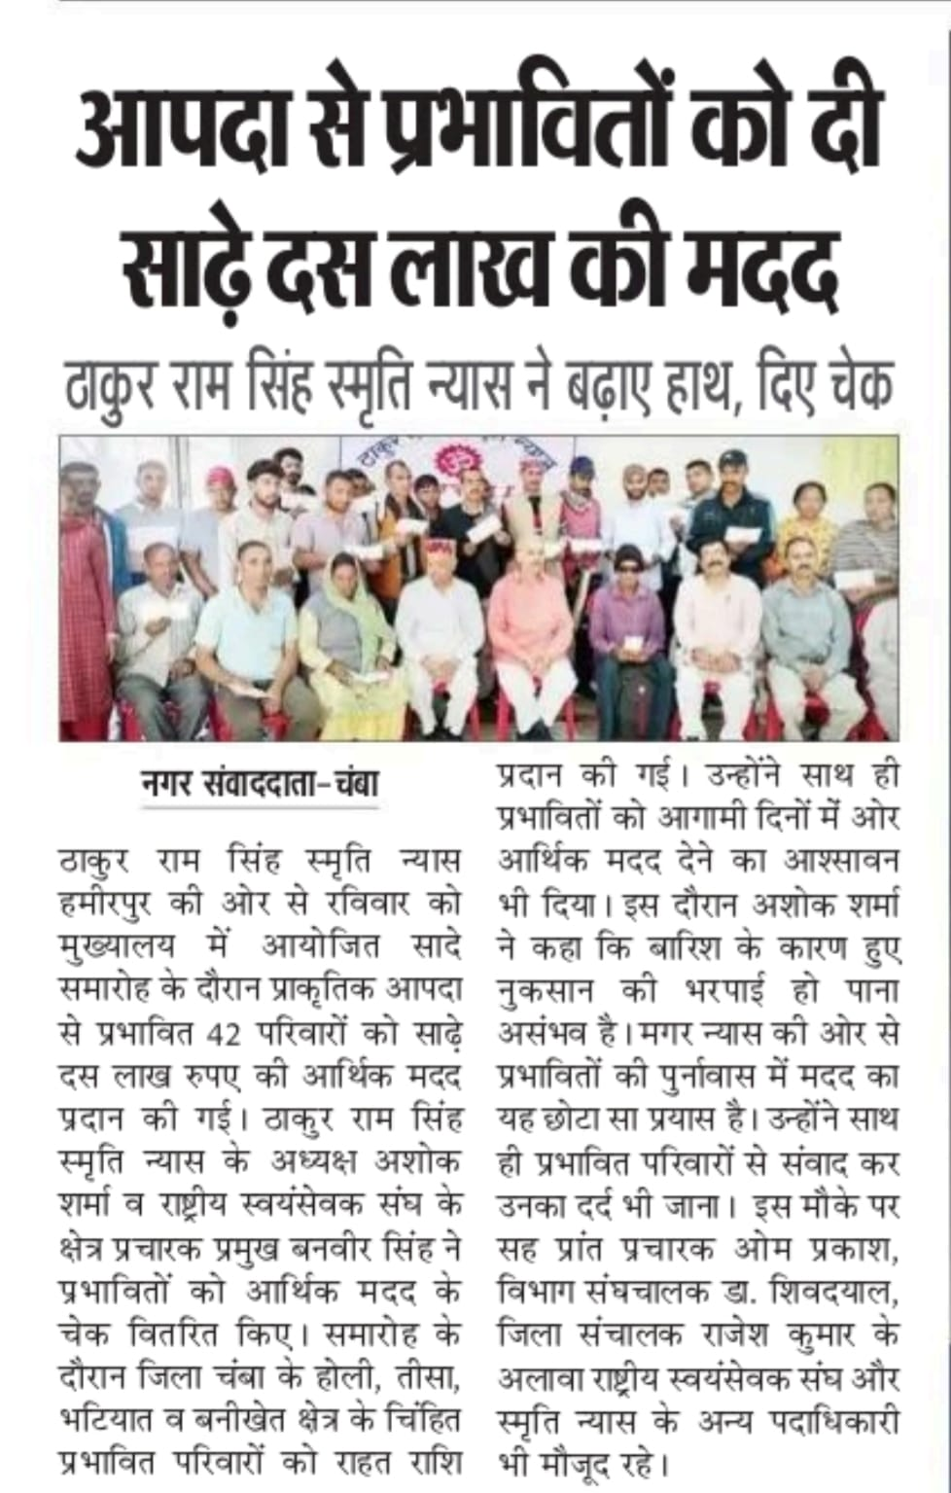
Figure 6. Clipping reporting assistance of approximately Rs 10 lakh to disaster-affected families and further assurance of support.
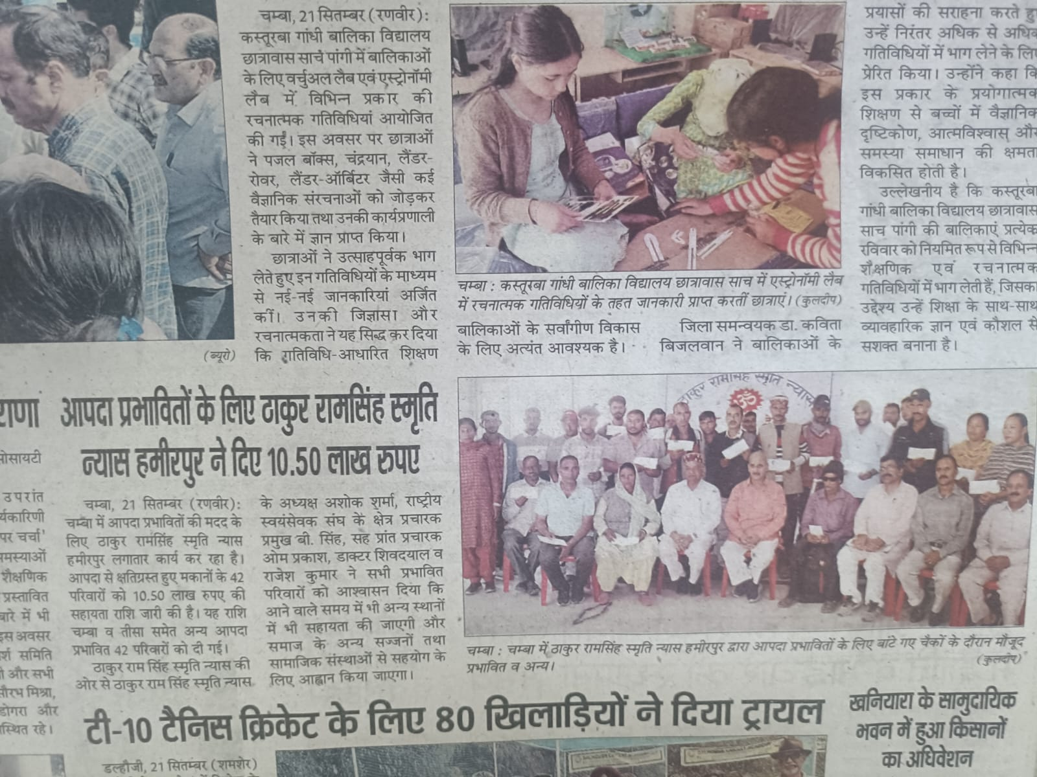
Figure 7. Clipping showing cheque distribution programme for affected families, with officials and local representatives present.
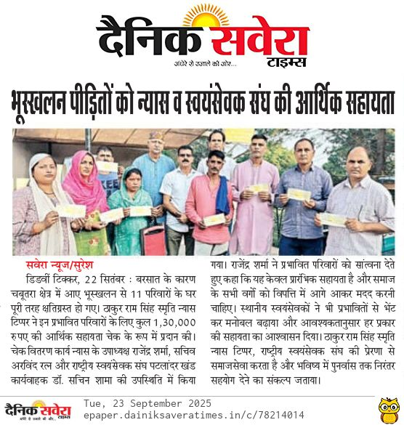
Figure 8. Dainik Savera clipping documenting Rs 1.30 lakh assistance to landslide-affected families.
Cheque handover is preferable to undocumented cash distribution because it creates an audit trail, identifies the date of assistance, and reduces later ambiguity. The clippings indicate that cheques were handed over in the presence of office bearers and local persons. This has two advantages. First, it increases public trust. Second, it allows the Trust to demonstrate that assistance was not merely announced but actually transferred.
For future handovers, the Trust should prepare a standard cheque-distribution sheet. It should include the beneficiary name, household location, type of damage, amount sanctioned, cheque number, date, signatures of beneficiary and two witnesses, and the name of the field verifier. If privacy is a concern, public reports can mention family counts and villages while the detailed beneficiary list remains with the Trust records.
The Trust should also record whether assistance is intended for immediate consumption, temporary shelter, repair, education, medical need, or livelihood restart. This will help measure impact. For example, if Rs 25,000 is given to a family, the Trust can later ask whether it was used for temporary rent, food, bedding, school needs or repair material. This does not mean controlling the family’s decision; it means understanding how relief helps in practice.

Impact of the Donation
The impact of the Trust’s donation can be divided into direct, indirect and institutional impact. Direct impact refers to immediate household support. Families receiving cheques could purchase essentials according to their priorities. Families receiving relief material received goods that could be used immediately. In a disaster setting, timing is crucial. A small amount received early may be more useful than a larger amount received after the household has already borrowed money at high cost.
Indirect impact refers to psychological and social benefits. Public assistance from a respected trust tells affected families that the community has not abandoned them. This matters in disaster recovery because confidence influences decision-making. A family that receives social support may be more willing to begin repairs, send children back to school, or seek official assistance. Relief therefore has a confidence multiplier.
Institutional impact refers to the strengthening of the Trust’s role as a credible humanitarian actor. The media coverage establishes public documentation. The use of cheques and visible field visits helps build donor confidence. The Trust can use this report to communicate with future donors, demonstrate accountability, and raise a dedicated disaster-relief corpus.
The documented assistance to 42 families through Rs 10.50 lakh implies an average of Rs 25,000 per family. The documented assistance to 11 landslide-affected families through Rs 1.30 lakh implies an average of approximately Rs 11,818 per family. These are meaningful amounts for immediate family-level relief, particularly when combined with community recognition and additional official support. The Rs 1.00 lakh cheque to the affected-family committee could have enabled committee-level distribution or coordinated assistance, though the exact number of final household beneficiaries is not specified in the uploaded clipping.
The Pandoh/Talwara intervention had a different impact profile. Material relief helps where logistics are broken and households cannot easily buy goods. Ration, blankets, rice, clothes and essential household goods are appropriate in the immediate relief phase. In-kind support is especially useful where markets are inaccessible, families have lost stored supplies, or cash cannot be readily converted into goods because transport and shops are disrupted.
The Trust’s approach therefore covered two important phases: relief-in-kind for survival and cheque assistance for early recovery. A stronger future model would add a third phase: follow-up support for education, livelihood tools, temporary rent or house repair. This would allow the Trust to move from one-time response to recovery partnership.
Impact channel | Observed or inferred effect | Measurement indicator for future
Consumption smoothing | Families can buy food, bedding, medicine or essentials without immediate distress borrowing | Follow-up record of main use of funds within 30 days
Temporary shelter support | Cash can support rent, repair material or household relocation needs | Number of families returning to safe shelter or securing temporary stay
Dignity and morale | Public recognition and respectful handover reduce isolation | Beneficiary feedback and community testimony
Community trust | Visible cheque handover and media coverage strengthen donor confidence | Number of repeat donors and size of disaster corpus
Institutional learning | Experience creates a template for future rapid response | Availability of forms, field registers and audit-ready documentation
Table 5. Impact pathways and future measurement indicators.

Analysis
The Trust’s disaster response shows several strengths. The first strength is speed. The July 2025 clipping indicates that relief material was sent during the active crisis period, not only after the disaster had left the news cycle. In mountain disasters, speed is especially valuable because connectivity can deteriorate quickly and households may face acute shortages.
The second strength is field presence. The uploaded images show people on the ground, not only office-level announcements. This matters because needs assessment cannot be fully remote. A field visit reveals whether a family has alternate shelter, whether roads are passable, whether elderly persons require special support, and whether relief material can actually reach the village.
The third strength is use of local networks. The clippings mention volunteers and social workers connected to Seva Bharati, local committees, Panchayat representatives and community leaders. Such networks provide trust and local intelligence. They can also reduce duplication by identifying which families have already received official or private assistance.
The fourth strength is traceability in monetary assistance. Cheque distribution creates a visible record. This is important for a trust because donors and auditors need to distinguish between announced donations and completed transfers. The Trust should build on this by preserving cheque numbers, bank statements and beneficiary acknowledgments.
The fifth strength is institutional financial base. The uploaded financial statements show a trust with significant assets and previous charitable activity. However, the declining donation income in 2024-25 is a concern. If disaster events become more frequent, the Trust should not rely only on spontaneous donations. It should establish a designated disaster corpus with annual contributions, emergency authorization rules and a minimum liquidity threshold.
The first limitation of the current evidence is that some clippings do not provide complete beneficiary lists, damage categories or final utilization details. This is normal for newspaper reporting but insufficient for internal impact reporting. Future documentation should maintain a confidential beneficiary register and a public summary.
The second limitation is the lack of stated valuation for in-kind relief material. The Pandoh/Talwara relief may have been highly valuable, but without quantity and value records, the Trust cannot fully represent the contribution in reports. Future material relief should record item, quantity, unit cost, source, transport cost and distribution location.
The third limitation is absence of follow-up data. A cheque handover is an output; recovery is an outcome. Future reports should record whether the family used funds for food, shelter, repair, education, medicine or livelihood restart. Even a simple 30-day follow-up call can produce valuable impact evidence.
The fourth limitation is that the uploaded financial statements are annual accounts, not intervention-level ledgers for the 2025 flood response. Therefore, this report can analyze institutional capacity and trends but cannot fully reconcile every 2025 relief payment against ledger entries without bank records, vouchers and beneficiary receipts. Those records should be attached in the final version if available.
Overall, the Trust’s work appears socially credible and operationally relevant. The next step is to make it more formally measurable. A trust that can show both compassion and data will be better positioned to attract donors, coordinate with authorities and respond to future disasters.
Strength/Gap | Finding | Recommended action
Strength | Rapid material relief and field service in Pandoh/Talwara area | Maintain pre-positioned relief kit lists for monsoon season
Strength | Cheque-based assistance to affected families | Preserve cheque numbers, acknowledgments and beneficiary list
Strength | Local volunteer and community network | Create trained rapid assessment teams by block/district
Gap | In-kind relief value not stated in clipping | Maintain stock, purchase and distribution registers
Gap | Limited follow-up data | Conduct 30-day and 90-day beneficiary follow-up
Gap | Donation income trend declined by 2024-25 | Build dedicated disaster corpus and donor campaign
Table 6. Analytical findings and recommended actions.

Recommendations and Way Forward
- Create a permanent Aapda Rahat Kosh with a board-approved minimum balance, emergency authorization rules and transparent annual disclosure.
- Adopt a standard disaster assessment form using the Household Vulnerability Index and Risk Priority Score proposed in this report.
- Maintain a disaster evidence register linking government reports, photographs, beneficiary lists, approval notes, cheque details and follow-up outcomes.
- Prepare pre-monsoon relief kits containing ration, bedding, hygiene materials, torch, basic medicines, school materials for children and sanitary items for women.
- Train block-level volunteers in rapid damage observation, ethical photography, beneficiary verification, safety protocols and coordination with Panchayat representatives.
- Use bank transfer or cheque wherever possible; where cash is unavoidable, use signed receipts and witness verification.
- Separate emergency relief, early recovery and livelihood-restoration budgets so that donors can choose the type of support they wish to fund.
- Publish a short annual disaster-relief impact note with total funds received, total funds disbursed, number of families supported, areas covered, and lessons learned.
- Create a donor communication package using this report, photographs, beneficiary stories and audited figures to rebuild the donation base.
- Coordinate with government departments and SDMA/DM Cell information so that Trust assistance complements official relief rather than duplicating it.

Conclusion
The 2025 Himachal monsoon disaster demanded both institutional response and community compassion. Thakur Ram Singh Smriti Nyas acted within this difficult environment by delivering relief material and financial assistance to affected families and committees. The uploaded evidence shows a humane response rooted in field presence and social responsibility.
The Trust’s work is significant not because it solved the entire disaster, but because it responded to real families at a critical time. Disaster recovery is built through many such acts: a ration kit delivered to an isolated household, a cheque given to a family that has lost stability, a visit that assures people they are not forgotten, and a public record that encourages others to contribute.
The report recommends that the Trust now convert this experience into a formal disaster-response model. With a permanent Aapda Rahat Kosh, scientific assessment tools, beneficiary registers, follow-up systems and annual impact reporting, the Trust can become an even stronger relief institution. In the memory of Thakur Ram Singh, the Trust can continue to demonstrate that service is most meaningful when it is timely, fair, transparent and grounded in the suffering of people.

References
Economic Times. (2025, August 1). Himachal Pradesh: Monsoon-related death toll rises to 173. The Economic Times.
Himachal Pradesh State Disaster Management Authority. (2026). PDNA 2025: Post Disaster Needs Assessment-2025. Government of Himachal Pradesh.
Hindustan Times. (2025, August 18). Monsoon fury leaves 263 dead in Himachal Pradesh; losses pegged at Rs 2,173 crore. Hindustan Times.
Ministry of Home Affairs, Government of India. (2025, July 20). Union Home Minister directs formation of a multi-sectoral central team in view of frequency and intensity of natural disasters in Himachal Pradesh. Press Information Bureau.
National Institute of Disaster Management. (2019). Post Disaster Needs Assessment India: Standard Operating Procedures. Ministry of Home Affairs, Government of India.
PreventionWeb. (n.d.). PDNA: Post-Disaster Needs Assessments. United Nations Office for Disaster Risk Reduction.
The Tribune. (2025, December 27). Year 2025: Calamities, rush to rebuild, mounting debt keep Himachal on edge. The Tribune.
The Tribune. (2025, September 1). Himachal Pradesh declared disaster-affected state as rain damages cross Rs 3,000 crore. The Tribune.
United Nations Development Programme. (n.d.). Post-Disaster Needs Assessment. UNDP.
Uploaded audited financial statements of Thakur Ram Singh Smriti Nyas, Himachal Pradesh for FY 2021-22, FY 2022-23, FY 2023-24 and FY 2024-25.
Uploaded newspaper clippings supplied by the Trust documenting relief material distribution and cheque handover events in July-September 2025.

Annexure A: Evidence Register of Uploaded Files
Evidence item | What it shows | Use in report
Pandhoh Srijan clipping dated 11 July 2025 | Relief material sent to Pandoh and volunteer service in Talwara area | Establishes immediate in-kind relief intervention
Hindi clipping on Rs 1 lakh assistance | Cheque assistance to affected-family committee in Rupnagar/Paonta context | Establishes documented monetary support
Hindi clipping on Rs 10 lakh/10.50 lakh assistance | Assistance to 42 disaster-affected families; public cheque handover | Establishes beneficiary count and major cash relief
Composite newspaper clipping dated 21 September 2025 | Coverage of Rs 10.50 lakh to 42 families and related community event | Corroborates major cash relief intervention
Dainik Savera clipping dated 23 September 2025 | Rs 1.30 lakh assistance to 11 landslide-affected families | Establishes additional location-specific relief
Audited accounts 2021-22 | Donation income, expenses, assets and charitable activity | Establishes institutional background
Audited accounts 2022-23 | Receipts/payments and balance sheet | Establishes financial trend
Audited accounts 2023-24 | Aapda Rahat Kosh, income/expenditure and balance sheet | Establishes disaster fund history
Audited accounts 2024-25 | Receipts/payments, income/expenditure and balance sheet | Establishes most recent financial context
Table 7. Evidence register based on user-uploaded files.

Annexure B: Tables Extracted from Audited Statements
The following figures were extracted from the uploaded annual statements and are used for institutional analysis. Figures should be reconciled with original ledgers, bank statements and vouchers before final statutory use.
Metric | 2021-22 | 2022-23 | 2023-24 | 2024-25
Donation income | Rs 4,810,243 | Rs 4,371,440 | Rs 3,632,497 | Rs 937,301
Interest/other income | Rs 189,876 | Rs 26,007 | Rs 36,520 | Rs 32,410
Total income | Rs 5,000,119 | Rs 4,397,447 | Rs 3,673,017 | Rs 969,711
Expenditure | Rs 2,520,406 | Not available as single statement total | Rs 2,177,714 | Rs 2,116,914
Net result | Rs 2,479,714 | Rs -2,791,925 | Rs 1,495,303 | Rs -1,147,203
Total assets/balance sheet total | Rs 14,505,312 | Rs 13,704,244 | Rs 16,240,046 | Rs 14,962,343
Fixed assets | Rs 11,148,772 | Rs 13,259,429 | Rs 14,672,346 | Rs 13,550,160
Current assets / closing current balance | Rs 1,060,547 | Rs 444,815 | Rs 1,567,701 | Rs 1,412,184
Table 8. Consolidated financial metrics from uploaded statements.

