Activities conducted in financial year 2025-2026
1. Independence Day Celebration and Community Programme – 15 August 2025
On the occasion of India’s 79th Independence Day, 15 August 2025, Thakur Ram Singh Smriti Nyas organized a community programme at Tipper, District Hamirpur, Himachal Pradesh, to mark the national celebration with a spirit of patriotism and public participation. The programme was conducted with the objective of honoring the nation’s freedom, promoting national values and encouraging unity and responsibility among community members.
The event witnessed the participation of local residents, youth, women and children from nearby villages. The celebration included flag hoisting, patriotic songs and community interaction, creating an atmosphere of pride and national unity. Participants remembered the sacrifices of freedom fighters and reflected on the importance of preserving the country’s values of service, discipline and social harmony.
The programme also served as an opportunity to encourage youth participation in nation-building and community welfare. The event was appreciated by attendees and reflected the trust’s continued commitment toward promoting patriotism, social awareness and community engagement through meaningful public programmes.
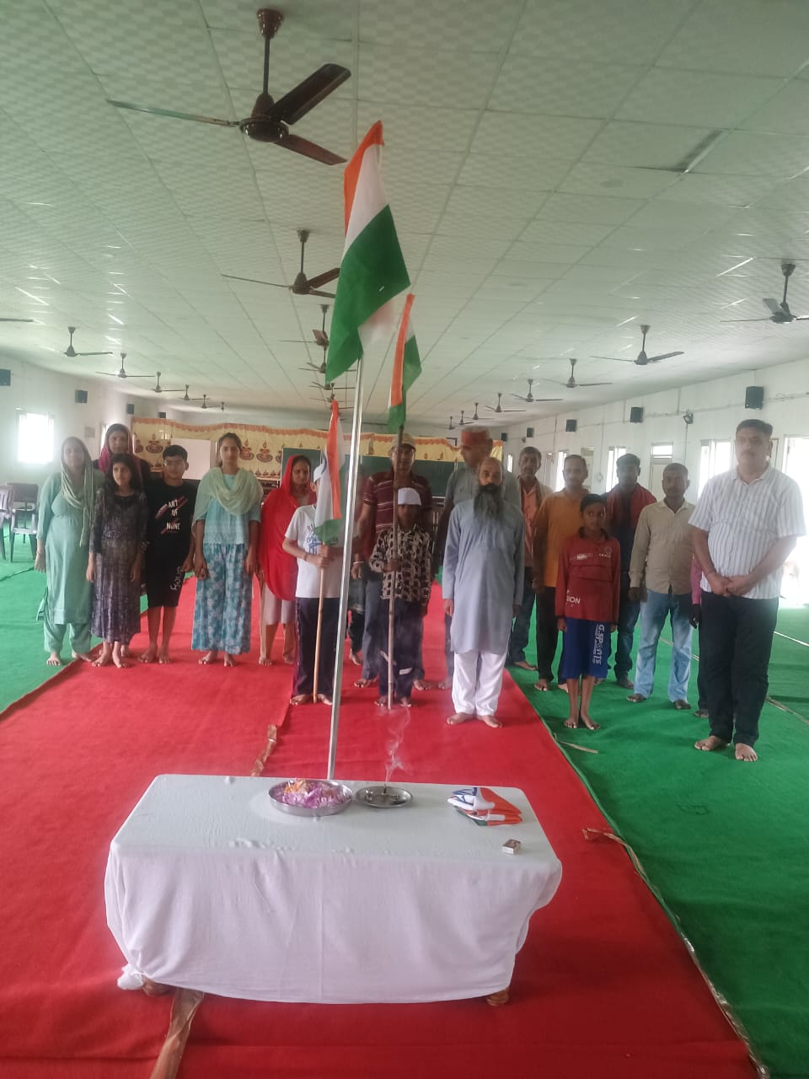
2. Disaster Relief Assistance (Apda Rahat) – 2025–26
Disaster Relief Assistance (Apda Rahat) – Pandoh and Talwara, Mandi District – July 2025
During the financial year 2025–26, Thakur Ram Singh Smriti Nyas, Hamirpur actively extended humanitarian assistance to families affected by floods and natural calamity in Pandoh and nearby villages of Talwara in Siraj Assembly constituency, District Mandi, Himachal Pradesh. Responding promptly to the difficult situation caused by heavy rainfall and flooding, the trust undertook relief efforts with the objective of reaching affected families with immediate support and essential supplies.
As part of the relief initiative, the trust sent a vehicle loaded with food grains, ration kits, blankets and tarpaulin sheets to the affected area. The relief material reached Pandoh on 10 July 2025 and was distributed among families in remote villages including Talwara, Parwada, Syanj, Kuklah and Sandhigala, where access had become difficult due to damaged roads and disrupted connectivity. The trust’s assistance was especially important in areas where government and non-government aid had not yet reached.
The distribution work was carried out with the support of Seva Bharti volunteers and local community members, who prepared and delivered relief kits directly to the affected households. Volunteers travelled on foot to several difficult-to-access villages to assess the ground situation and ensure that assistance reached deserving families in time. Their dedication and field-level support played an important role in making the relief effort effective and timely.
The initiative reflected the trust’s spirit of compassion and social responsibility during a time of crisis. By providing immediate relief material and extending support to flood-affected families, Thakur Ram Singh Smriti Nyas reaffirmed its continued commitment toward humanitarian service, disaster response and community welfare.
The relief work was appreciated by local residents and served as a meaningful contribution toward supporting affected communities and standing with them during a challenging period of natural disaster.
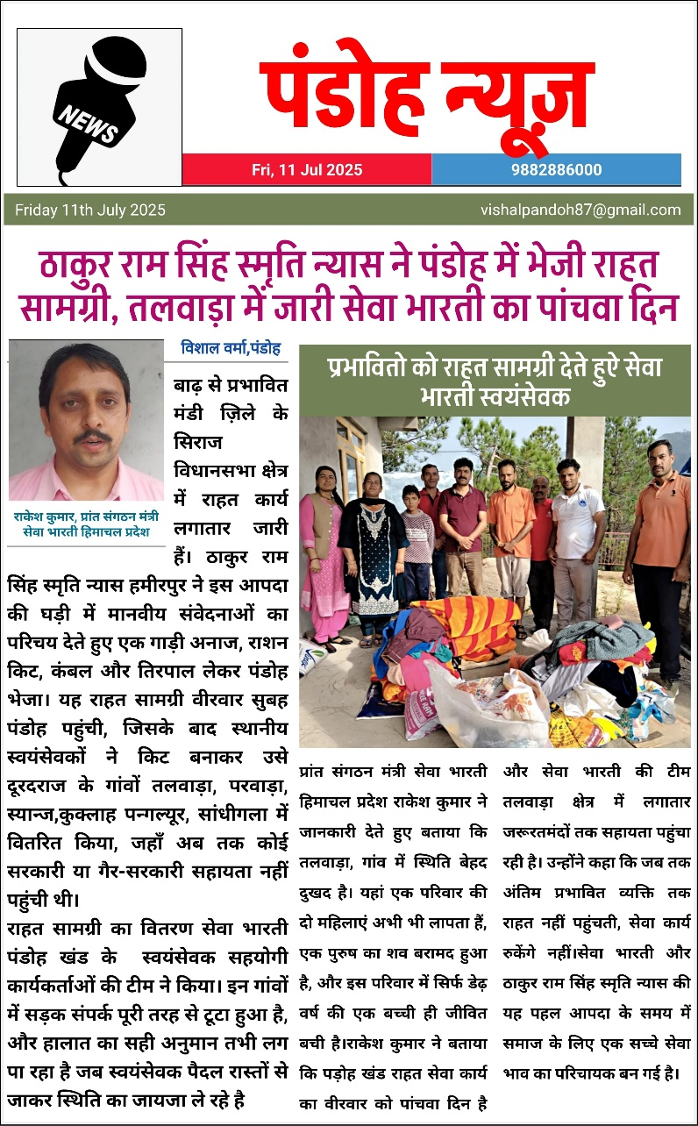
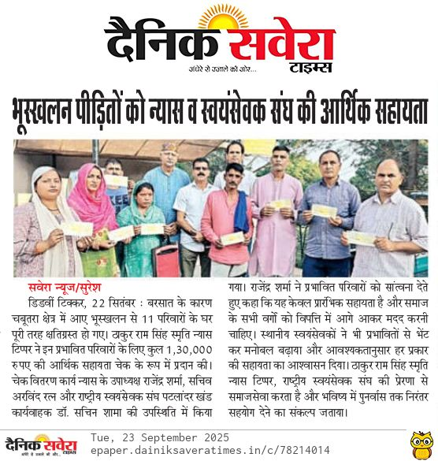
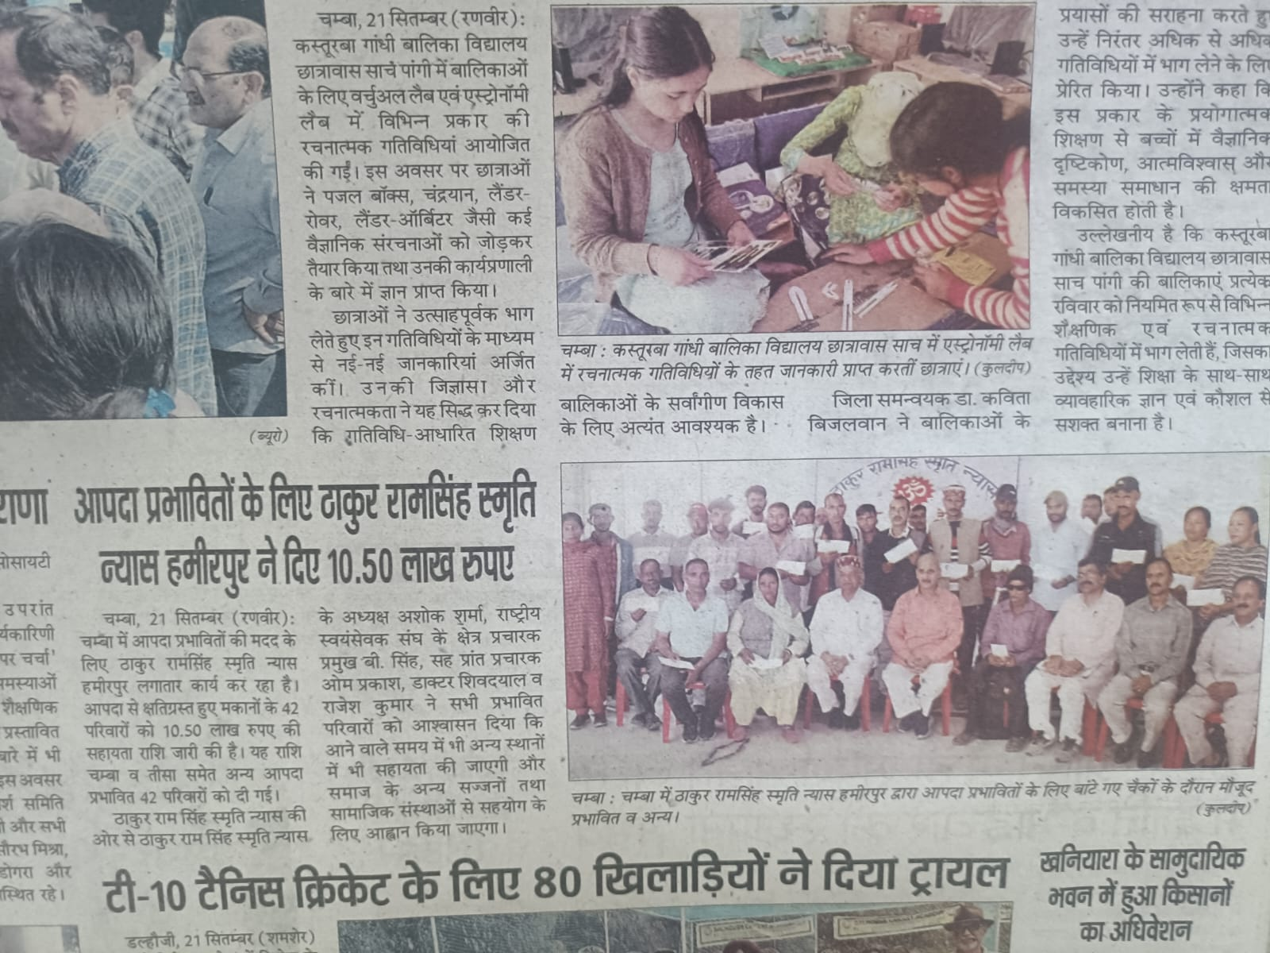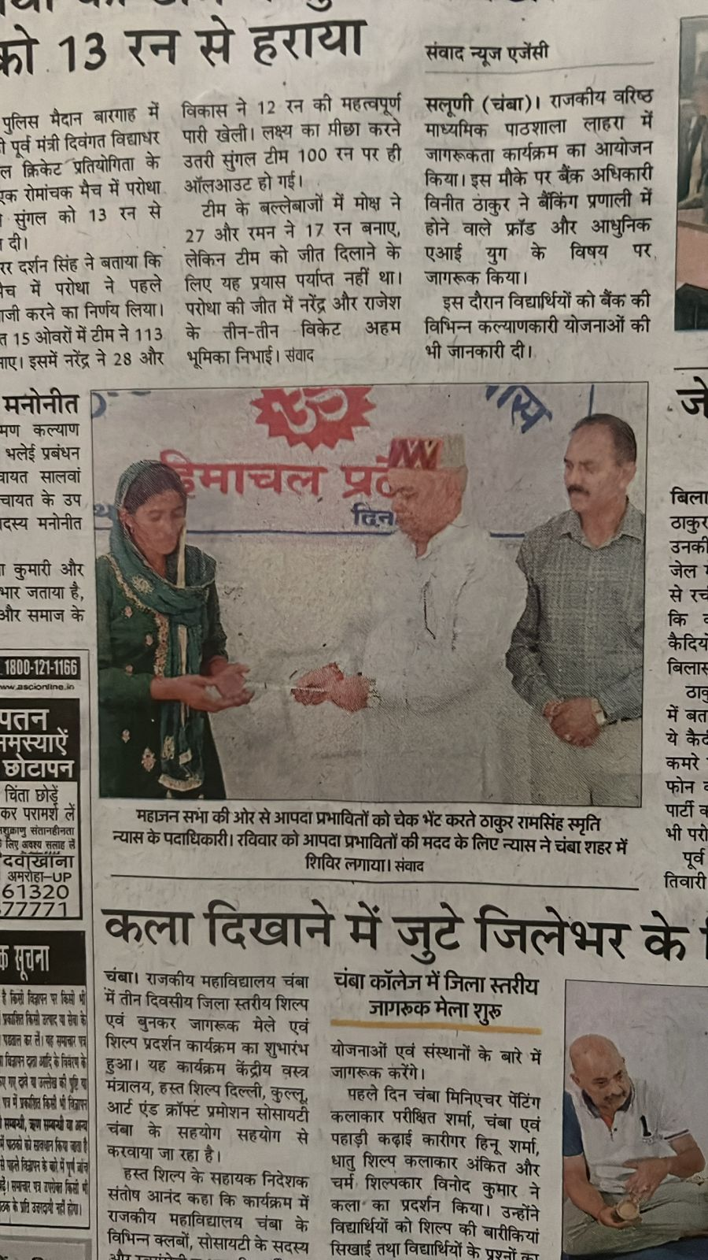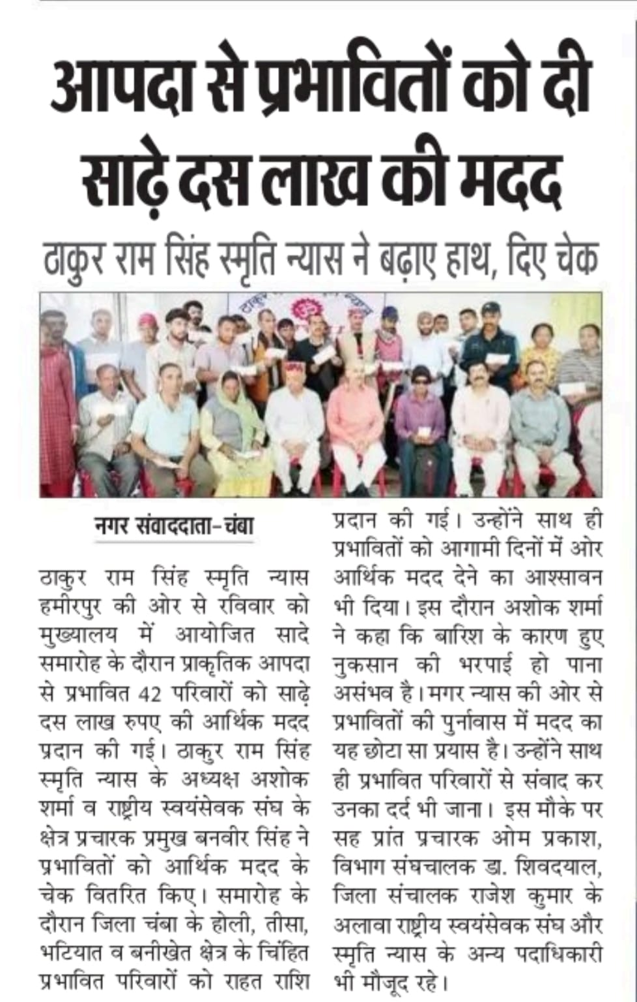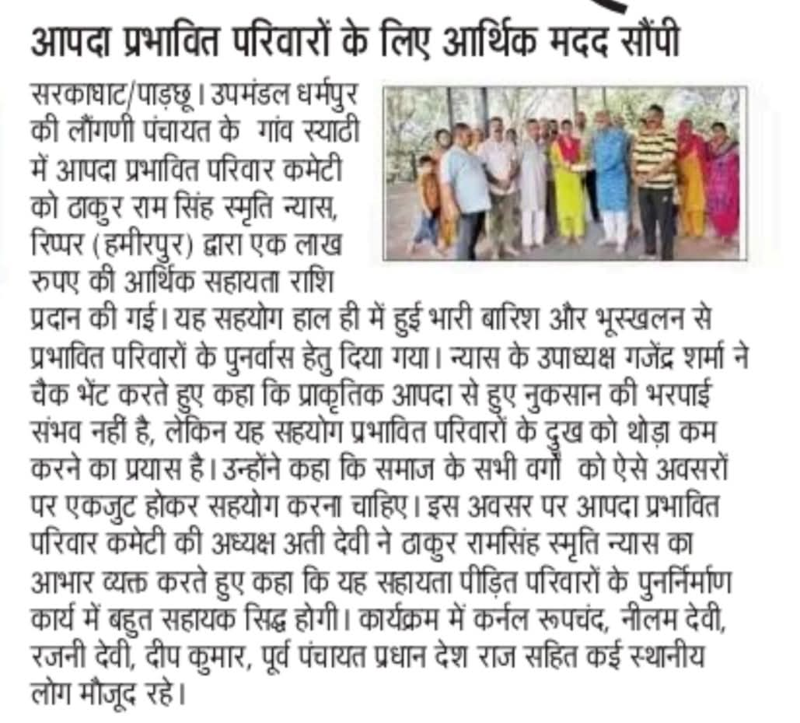
3. Blood Donation Camp – 2025–26
During the financial year 2025–26, Thakur Ram Singh Smriti Nyas organized a Blood Donation Camp as part of its ongoing public health and humanitarian initiatives. The programme was conducted with the objective of encouraging voluntary blood donation and supporting emergency medical requirements.
The camp saw active participation from local residents and youth volunteers, who came forward enthusiastically to donate blood. The initiative helped create awareness about the importance of blood donation as a life-saving act and encouraged community participation in healthcare support.
The programme reflected the trust’s continued commitment toward public health, social service and humanitarian welfare, while also strengthening awareness regarding the importance of regular voluntary blood donation.
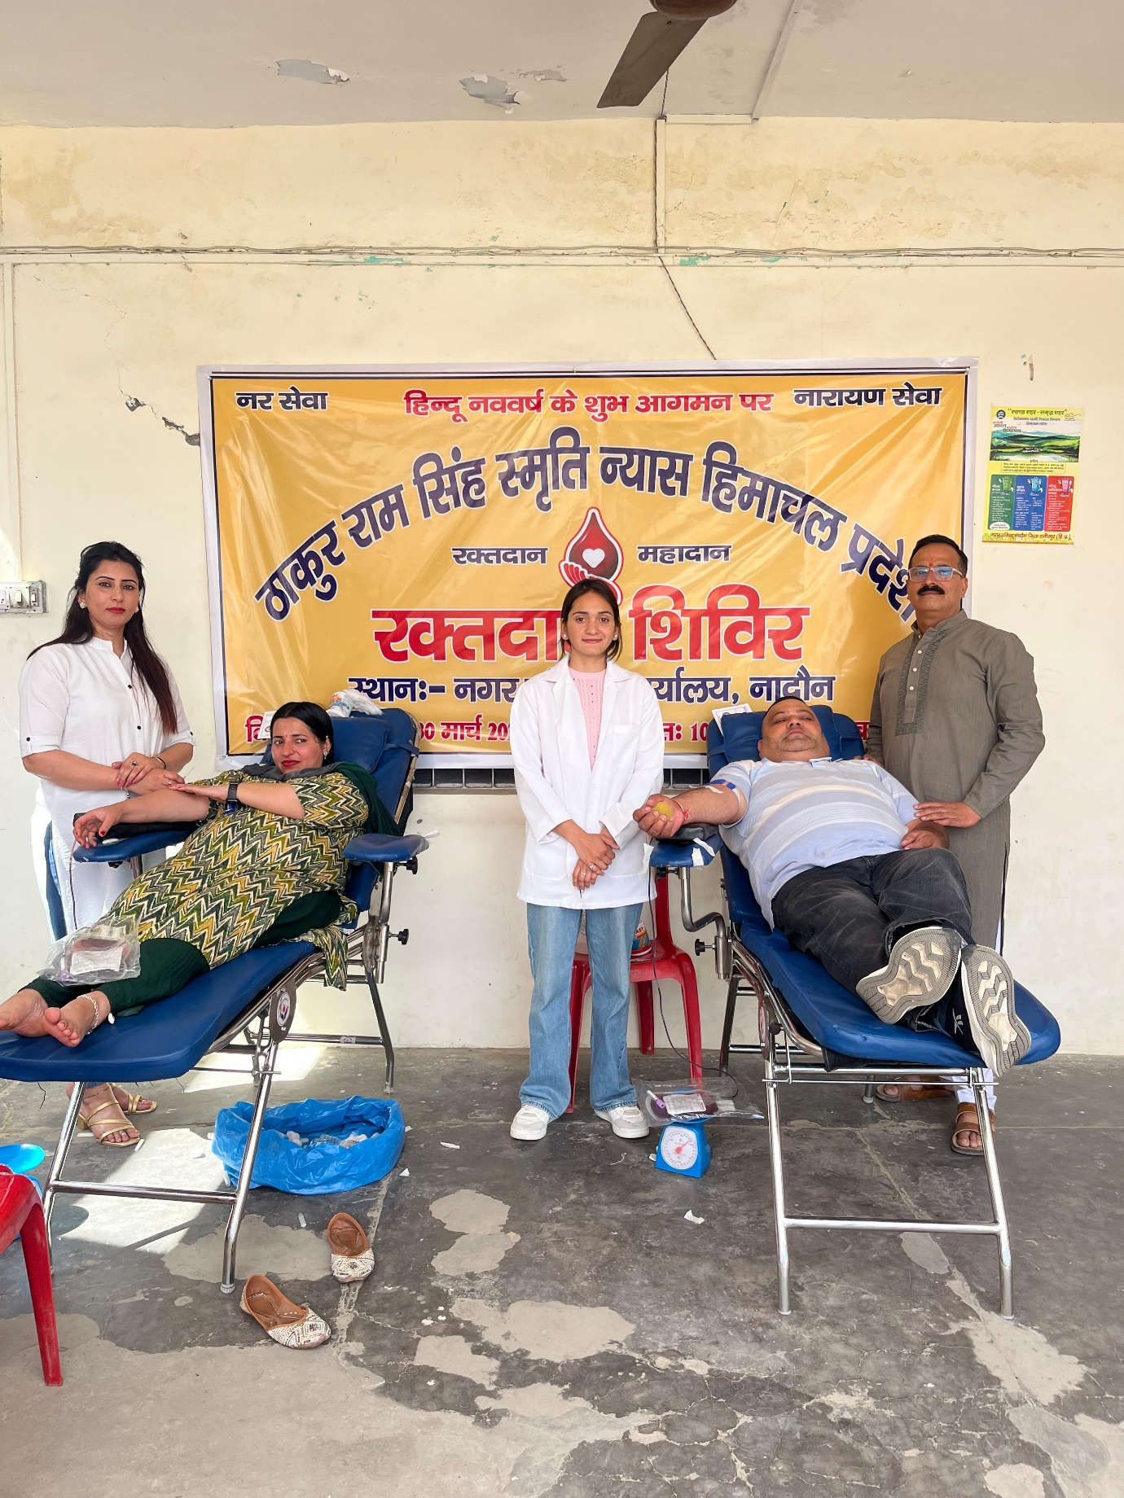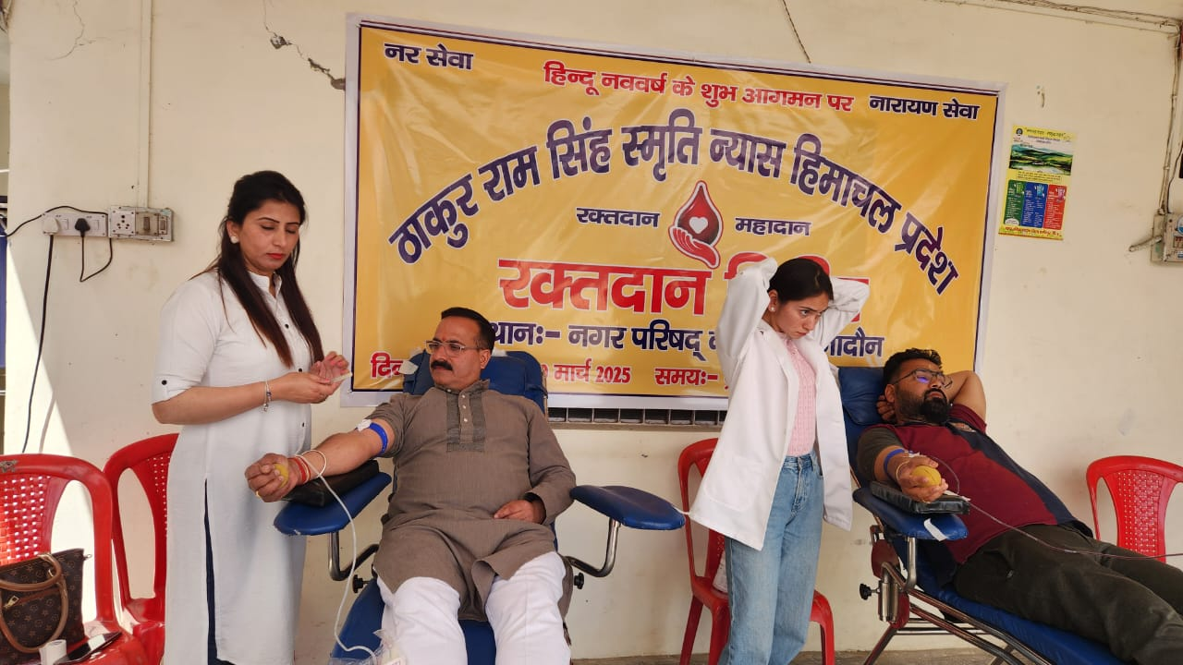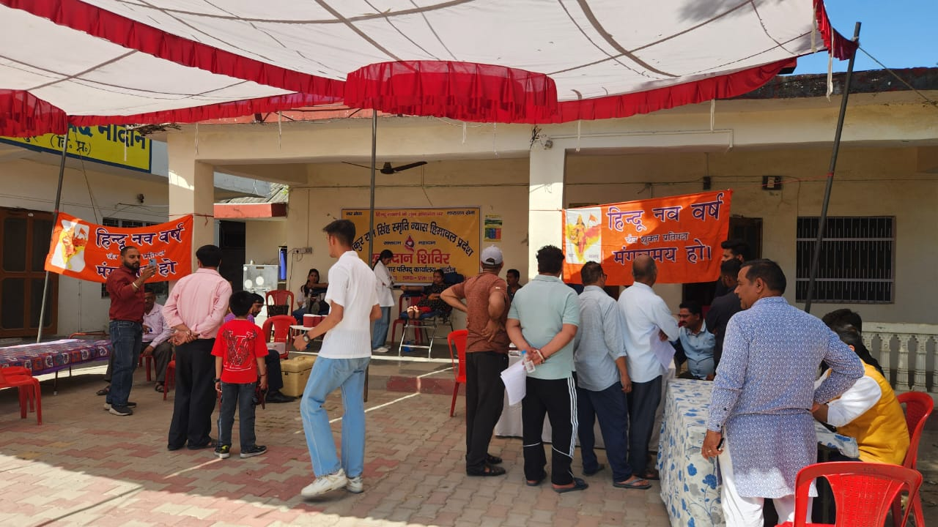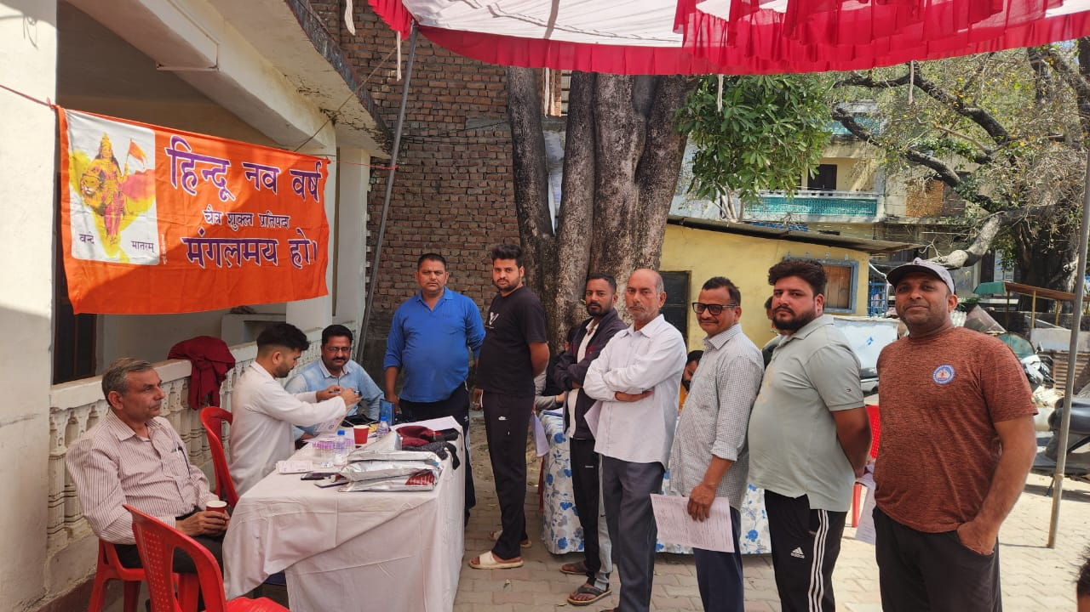
4. Vivah Mein Sahyog (Marriage Assistance Programme) – 2025–26
Marriage Assistance (Vivah Mein Sahyog) – FY 2025–26
During the financial year 2025–26, Thakur Ram Singh Smriti Nyas extended support under its “Vivah Mein Sahyog” initiative to Shilpa, daughter of Shri Kulyant, and Smt. Vimala Devi of Pahal, by providing financial assistance of ₹31,000 toward marriage-related arrangements. The assistance was extended as part of the trust’s welfare outreach with the objective of supporting economically weaker families and helping reduce financial burden during important family occasions.
The initiative was undertaken with a spirit of compassion and community responsibility, recognizing the practical challenges faced by families while arranging marriage ceremonies. By extending timely financial support, the trust aimed to help the family conduct the marriage with dignity and ensure that essential arrangements could be managed with greater ease.
Through this initiative, the trust continued its efforts to provide meaningful assistance to deserving families and strengthen community-based support during significant life events. The programme also reflected the values of cooperation and social responsibility, while promoting the idea that collective support can make an important difference for families in need.
The “Vivah Mein Sahyog” initiative reflected the trust’s continued dedication toward social welfare, humanitarian assistance and community support, especially for families requiring timely help. Through such efforts, Thakur Ram Singh Smriti Nyas continued to promote compassion, dignity and meaningful grassroots support while strengthening its long-standing commitment to public welfare and social service.
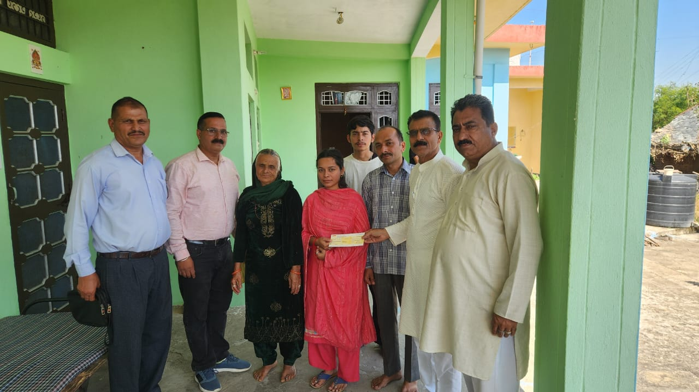

Traditional Wrestling (Dangal) Support and Promotion of Rural Sports – Galore
During the financial year 2025–26, Thakur Ram Singh Smriti Nyas extended support toward the promotion and preservation of traditional rural sports by contributing to a Dangal (traditional wrestling event) organized at Galore, District Hamirpur, Himachal Pradesh. The initiative was undertaken with the objective of encouraging youth participation in sports and preserving the rich tradition of indigenous games in rural communities.
As part of the programme, the trust provided financial assistance of ₹21,000 to the organizers of the wrestling event. The contribution was made to support the smooth conduct of the programme and to encourage continued organization of traditional sporting events at the grassroots level.
The event witnessed enthusiastic participation from local residents, youth and sports enthusiasts from nearby areas. The wrestling competition created an atmosphere of energy and community participation while highlighting the cultural significance of traditional rural games. Such events continue to play an important role in preserving local heritage and providing a healthy platform for physical fitness and sportsmanship among younger generations.
Representatives of the trust, including Vice President Rajendra Sharma and Secretary Arvind Ratan, were present on the occasion and extended their support to the organizers. Their participation reflected the trust’s continued encouragement toward programmes that strengthen community engagement and preserve regional cultural traditions.
The initiative reflected the trust’s commitment toward youth development, promotion of sports and preservation of traditional cultural practices. By supporting rural sporting activities like wrestling, Thakur Ram Singh Smriti Nyas continued its efforts to encourage discipline, teamwork and community participation while safeguarding the heritage of traditional Indian sports.
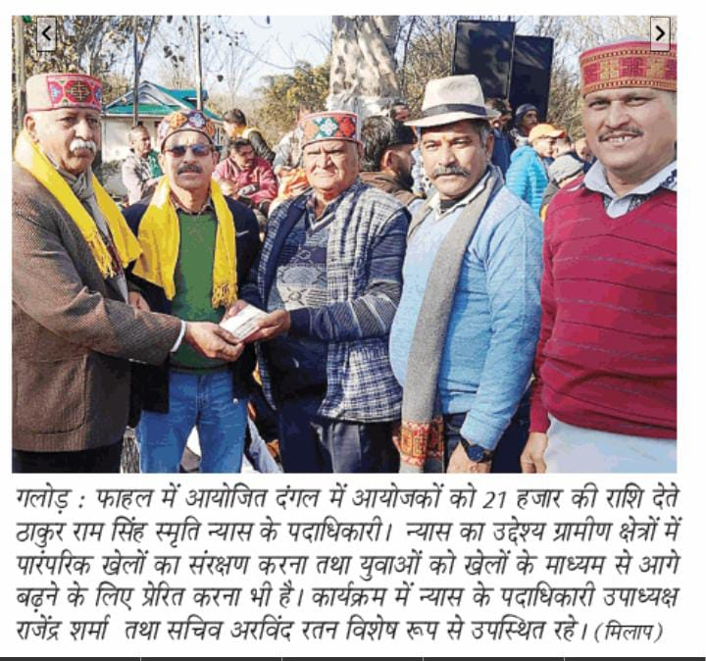
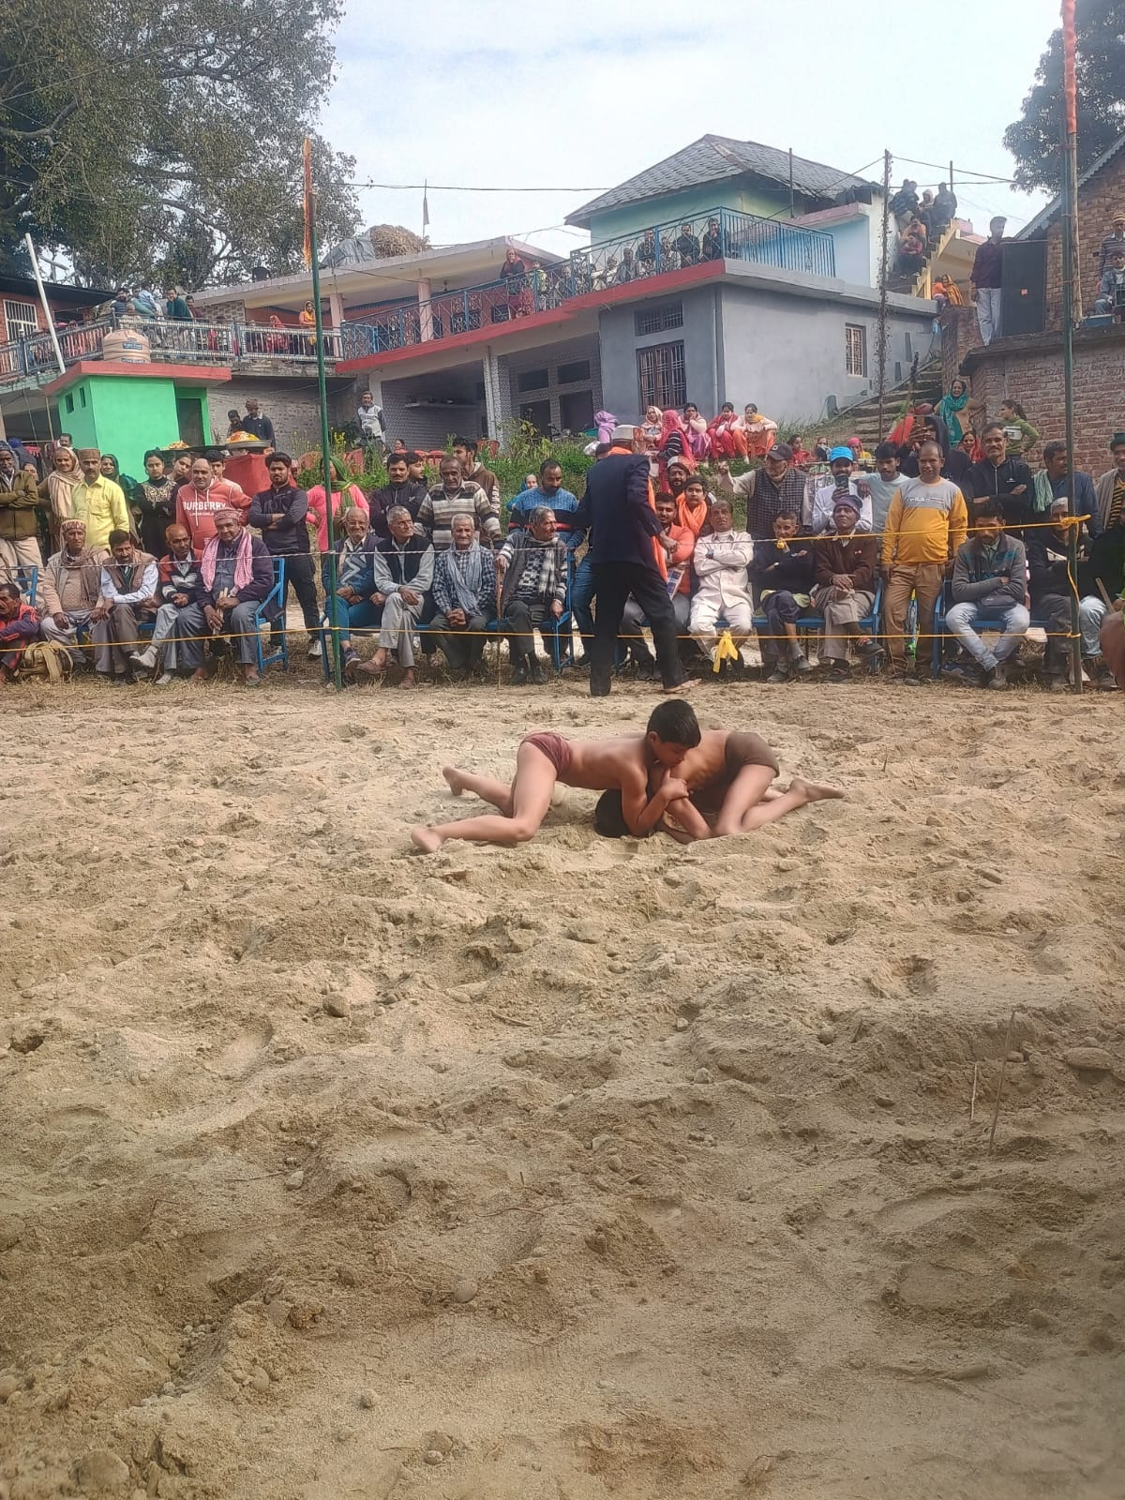

Blood Donation Camp – Rani Lakshmi Bai Park, Hamirpur – 23 March 2026
On 23 March 2026, Thakur Ram Singh Smriti Nyas organized a Blood Donation Camp at Rani Lakshmi Bai Park, Bus Stand, Hamirpur, Himachal Pradesh, as part of its ongoing commitment toward public health and humanitarian service. The programme was organized with the objective of encouraging voluntary blood donation and strengthening support for emergency medical requirements and patient care.
The camp witnessed active participation from local residents, youth volunteers and members of the surrounding community, who came forward with enthusiasm and a spirit of service to donate blood. The event created a positive atmosphere of social responsibility and community participation, with donors contributing voluntarily toward a life-saving cause.
Medical personnel and supporting staff ensured smooth arrangements for donor registration, health screening and safe blood collection throughout the programme. Participants were also made aware of the importance of regular voluntary blood donation and how donated blood supports emergency treatment, surgeries and patients in need of immediate medical assistance.
The blood donation camp served as an important public awareness initiative, encouraging people—especially youth—to actively participate in humanitarian efforts and contribute toward strengthening healthcare support in the district. The programme also reinforced the message that a simple act of blood donation can become a vital source of help for someone in urgent need.
The successful organization of the camp reflected the trust’s continued dedication toward public health awareness, humanitarian welfare and community service. Through initiatives like these, Thakur Ram Singh Smriti Nyas continues to promote compassion, voluntary service and active community participation for the welfare of society.
