Activities Undertaken During Financial Year 2023–24
1. Conference on “Hindutva ki Avadharna” – 25 April 2023
On 25 April 2023, Thakur Ram Singh Smriti Nyas organized an intellectual conference on the theme “Hindutva ki Avadharna” at Lalit Palace, Didwin Tikker, District Hamirpur, Himachal Pradesh. The conference was conducted with the objective of creating awareness and encouraging thoughtful discussion on Indian cultural values, the philosophical understanding of Hindutva, and its relevance in contemporary society. The programme served as an important platform for dialogue on themes connected with national identity, social harmony, and the cultural foundations of Indian civilization.
The event witnessed the participation of around 350 people, including scholars, social workers, youth, and members of the local community. The large turnout reflected the strong public interest in understanding India’s civilizational heritage and engaging in meaningful discussions related to society and nation-building.
The keynote address was delivered by Dr. Chander Prakash Ji, Associate Professor, Department of Civil Engineering, NIT Hamirpur, who shared his insights on the broader concept of Hindutva as a cultural and civilizational identity rooted in values such as inclusiveness, service, unity, and social responsibility. He highlighted the importance of preserving Indian traditions while adapting them positively to meet present-day social challenges. His address encouraged participants to understand Indian thought not merely as a historical legacy but as a guiding force for ethical and social development in modern times.
The conference created a constructive atmosphere for intellectual exchange, where participants openly discussed ideas and perspectives related to Indian philosophy, cultural consciousness, and community responsibility. The programme also strengthened dialogue among attendees on matters of social and national importance and inspired active participation from people across age groups.
The successful organization of this conference reflected the continued commitment of Thakur Ram Singh Smriti Nyas toward promoting awareness, preserving Indian cultural values, and encouraging social harmony through educational and community-oriented programmes. The event was appreciated by attendees and contributed meaningfully to the trust’s larger vision of public awareness and social upliftment.

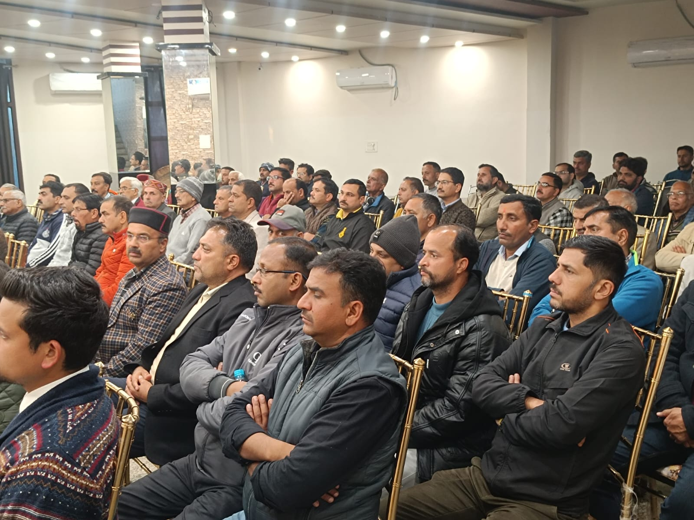

2. International Yoga Day Celebration – 21 June 2023
On the occasion of International Yoga Day, 21 June 2023, Thakur Ram Singh Smriti Nyas organized a large-scale yoga programme at the Trust Headquarters, Tipper, District Hamirpur, Himachal Pradesh. The programme was conducted with the aim of spreading awareness about the importance of yoga as an integral part of a healthy lifestyle and encouraging people to adopt regular wellness practices for physical, mental and emotional well-being.
The event witnessed enthusiastic participation from nearly 40 people, including youth, senior citizens, women and residents from nearby villages and surrounding areas. The large turnout reflected growing awareness in the community regarding the importance of health, fitness and preventive wellness. Participants came together in a spirit of unity and discipline to observe the day and take part in the guided yoga session.
The programme was conducted under the guidance of Yog Acharya Shri Bhumesh Ji from AIIMS Bilaspur, whose presence added great value to the event. He led participants through a series of yoga postures, breathing exercises and meditation techniques, while also explaining the practical benefits of yoga in daily life. He highlighted how regular yoga practice helps improve flexibility, physical strength and immunity, while also reducing stress, improving concentration and promoting inner peace. His session encouraged participants to understand yoga not only as physical exercise but as a complete discipline for balanced living.
Along with practical demonstrations, awareness was also created regarding the importance of maintaining a healthy routine, adopting positive habits and integrating yoga into everyday life. The event promoted community participation in wellness-oriented activities and inspired people of all age groups to make yoga a regular part of their lifestyle.
The successful celebration of International Yoga Day reflected the trust’s commitment toward public health awareness, community well-being and value-based social initiatives. The programme was widely appreciated by participants and served as a meaningful effort in encouraging healthy living, collective participation and a stronger sense of physical and mental well-being within the community.
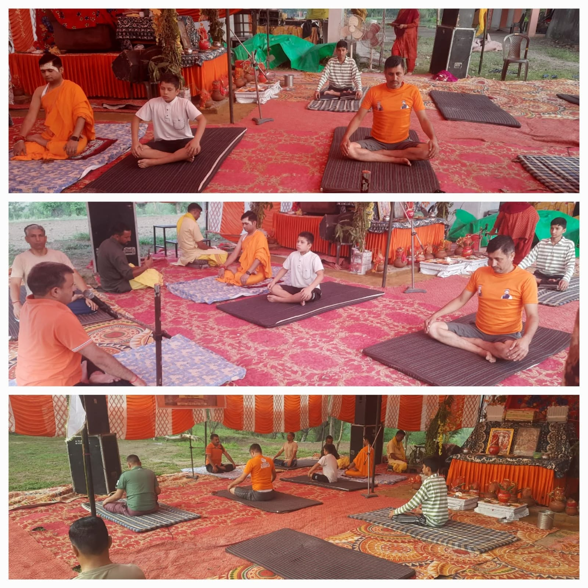

3. Three-Day Agricultural Awareness Camp – 11 to 13 August 2023
A three-day Agricultural Awareness Camp was organized by Thakur Ram Singh Smriti Nyas at Tipper, District Hamirpur, Himachal Pradesh, from 11 to 13 August 2023 for farmers from nearby villages and surrounding rural areas. The programme was conducted with the objective of strengthening agricultural awareness, promoting sustainable farming practices and supporting rural livelihoods through practical knowledge-sharing and community participation.
The camp was organized in collaboration with Bhartiya Kisan Sangh, combining the trust’s community outreach efforts with the organization’s agricultural expertise and grassroots engagement with farmers. As part of the collaboration, Thakur Ram Singh Smriti Nyas provided the basic infrastructure and essential amenities required for the successful conduct of the camp, including arrangements for the venue, seating, logistical support and facilities for participants throughout the three-day programme.
The camp witnessed the active participation of around 180 farmers, who attended the sessions with great enthusiasm and interest. Farmers from different villages came together to learn about current agricultural challenges, improved cultivation methods and practical approaches that could help increase productivity while preserving natural resources. The programme created a valuable learning environment and encouraged direct interaction between agricultural experts and the farming community.
During the camp, experts shared practical knowledge on improved agricultural practices, including soil management, crop planning, water conservation and methods to enhance farm productivity. Special emphasis was placed on sustainable and eco-friendly farming techniques, encouraging farmers to adopt farming approaches that protect soil health, improve crop quality and reduce long-term environmental impact.
An important focus of the programme was indigenous cow-based organic farming methods, where participants were introduced to traditional and natural farming practices based on the use of cow-derived products such as organic manure and natural agricultural formulations. Experts explained how these methods can strengthen soil fertility, reduce dependence on chemical inputs and support healthier agricultural production. The sessions also emphasized the importance of preserving indigenous agricultural wisdom while integrating it with practical and modern farming knowledge.
The camp further served as an important platform for interaction and exchange of ideas among farmers, where participants openly discussed their experiences, local agricultural concerns and practical solutions suited to regional farming conditions. This exchange strengthened community participation, encouraged collective learning and created a supportive environment for sharing valuable field-level knowledge.
The successful organization of the Agricultural Awareness Camp reflected the trust’s continued commitment toward rural development, agricultural empowerment and environmentally sustainable farming practices. Through its collaboration with Bhartiya Kisan Sangh and by providing essential infrastructure and participant amenities, the trust contributed meaningfully to supporting farming communities, encouraging self-reliance and promoting responsible agricultural methods for long-term rural prosperity.

4. Blood Donation Camp – 5 November 2023
A Blood Donation Camp was organized by Thakur Ram Singh Smriti Nyas on 5 November 2023 at Saloni near Barsar, District Hamirpur, Himachal Pradesh, in collaboration with the local health authorities. The programme was organized with the objective of promoting voluntary blood donation, supporting emergency medical care and encouraging humanitarian service through community participation.
The camp witnessed active participation from local residents, youth volunteers and members of the surrounding communities. A total of 46 blood donors voluntarily donated blood during the programme, making a meaningful contribution toward healthcare support and helping strengthen the availability of blood for emergency medical requirements and patients in need.
The programme was conducted with the support and guidance of health authorities, who ensured proper medical arrangements, donor registration and safe blood collection procedures throughout the camp. Medical personnel also guided participants on the importance of regular blood donation, donor eligibility and the health benefits associated with voluntary blood donation. Their support helped ensure the smooth and successful organization of the camp.
The event also served as an important awareness initiative, encouraging people to understand blood donation as a vital humanitarian responsibility and a life-saving contribution to society. Participants were informed about the importance of maintaining adequate blood supplies for accident cases, emergency treatment and critical medical care. The programme inspired many community members, especially youth, to actively take part in social welfare efforts through voluntary service.
The successful organization of the Blood Donation Camp reflected the trust’s continued commitment toward public health, humanitarian support and community welfare. Through active collaboration with health authorities and strong participation from local residents, the initiative contributed meaningfully toward spreading awareness on voluntary blood donation and strengthening community-based healthcare support in the region.
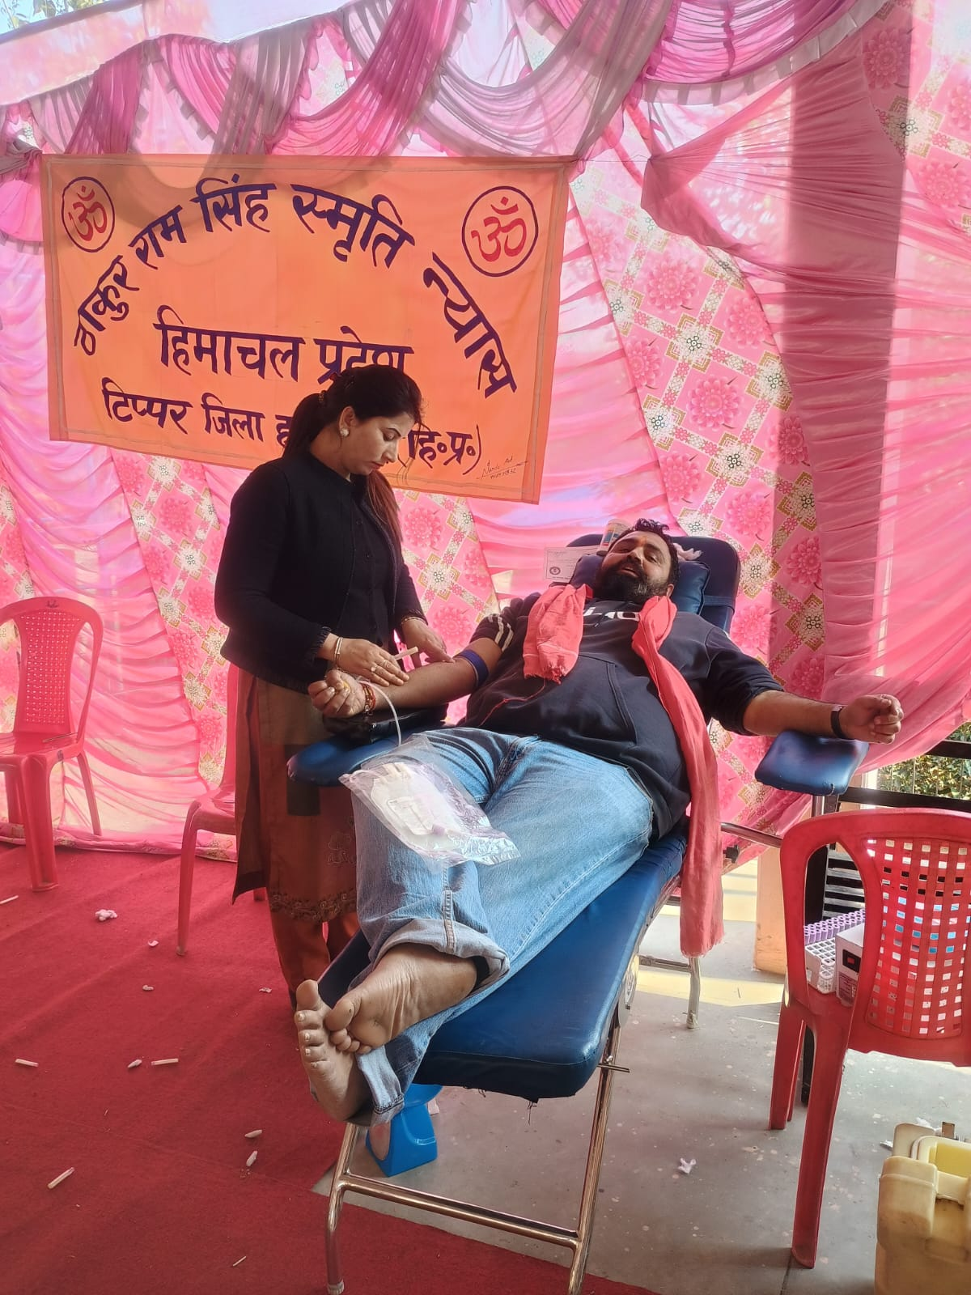

5. Blanket Distribution Drive – Winter 2023–24
During the winter season of 2023–24, Thakur Ram Singh Smriti Nyas organized a Blanket Distribution Drive for economically weaker families in villages of the Nadaun block, District Hamirpur, Himachal Pradesh. The initiative was undertaken as part of the trust’s regular welfare outreach with the objective of providing relief and support to vulnerable households during the harsh winter months.
Keeping in view the severe cold conditions in rural areas, the trust identified families requiring immediate assistance and distributed blankets among needy households across villages in the Nadaun region. The support was aimed particularly at helping economically weaker families, elderly individuals and those facing difficulty during the winter season. The distribution brought timely relief and helped ensure basic comfort and protection against the cold weather.
The drive was carried out through active community outreach and direct interaction with local residents, allowing assistance to reach deserving families effectively. Volunteers associated with the trust participated in the distribution process and helped coordinate the programme smoothly in different villages. The initiative was appreciated by local residents and served as a meaningful support during the winter period.
Beyond immediate relief, the programme reflected the trust’s broader commitment toward social welfare, humanitarian support and community care, especially for those in need during difficult seasonal conditions. By extending direct assistance to vulnerable families, the trust continued its efforts to promote compassion, community responsibility and timely welfare support at the grassroots level.
The Blanket Distribution Drive formed an important part of the trust’s welfare activities during the financial year and demonstrated its continued dedication toward supporting underprivileged sections of society and strengthening community-based humanitarian outreach in rural areas.
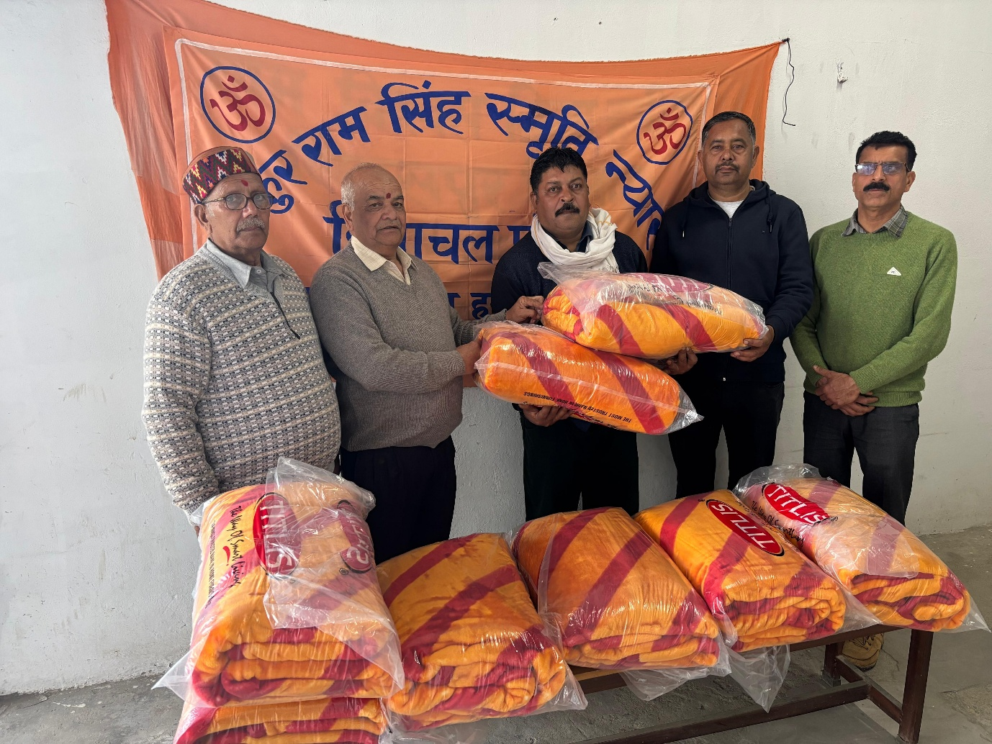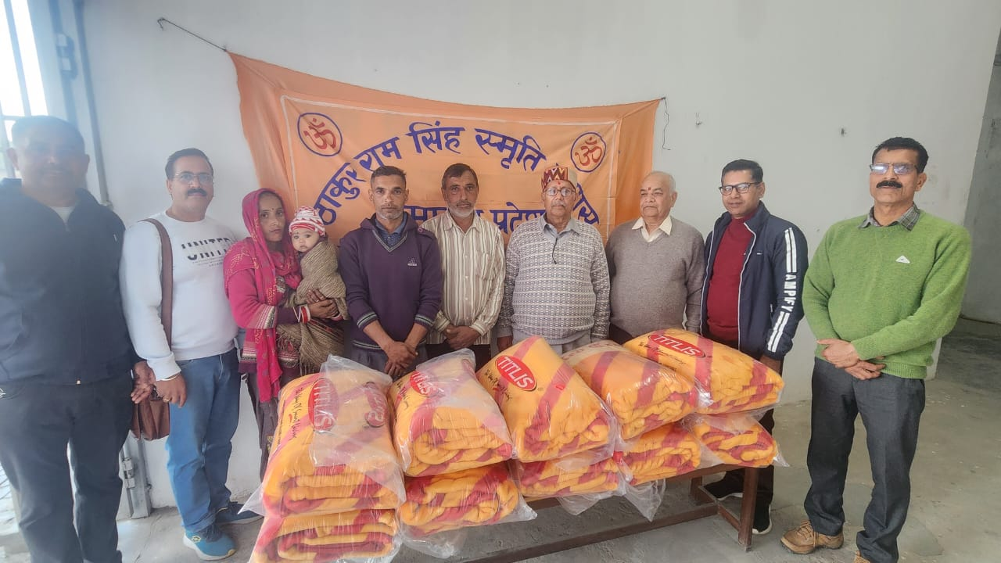

6. Gita Mahotsav and Gita Distribution Programme – Bhadru, Dhaneta
As part of its efforts to promote Indian spiritual values and cultural awareness, Thakur Ram Singh Smriti Nyas organized a Gita Mahotsav and Gita Distribution Programme at Krishna Gopal Temple, Bhadru, Dhaneta, District Hamirpur, Himachal Pradesh during the year. The programme was conducted with the objective of encouraging awareness and understanding of the teachings of the Bhagavad Gita and inspiring people to connect with India’s spiritual and cultural heritage.
The event witnessed participation from devotees, local residents, youth and members of the surrounding villages, who gathered at the temple in a devotional and respectful atmosphere. The programme highlighted the timeless teachings of the Bhagavad Gita and their importance in guiding individuals toward righteous conduct, inner discipline, service and harmony in daily life.
A special part of the programme was the distribution of Bhagavad Gita copies among participants, with the aim of encouraging regular reading and understanding of the sacred text. The books distributed during the programme were arranged with the support of Pandit Brahm Jyoti Group, Bangana, District Una, whose contribution added meaningful value to the event and helped ensure wider participation in this spiritual initiative.
The programme created an atmosphere of devotion and collective participation, while also strengthening awareness regarding Indian philosophical traditions and cultural values within the local community. Participants appreciated the initiative and welcomed the opportunity to receive and engage with the teachings of the Bhagavad Gita.
The successful organization of Gita Mahotsav reflected the trust’s continued commitment toward cultural preservation, spiritual awareness and community outreach. Through programmes of this nature, the trust continued to encourage value-based learning, social harmony and a deeper connection with India’s rich spiritual heritage.

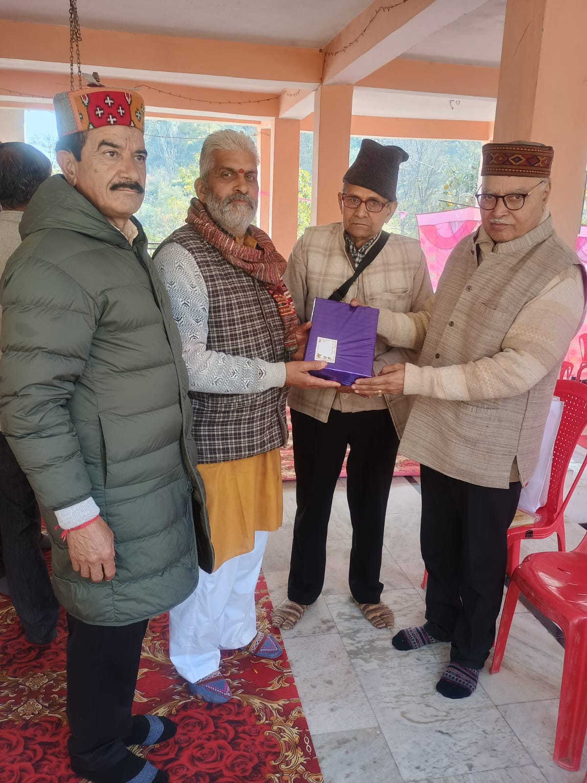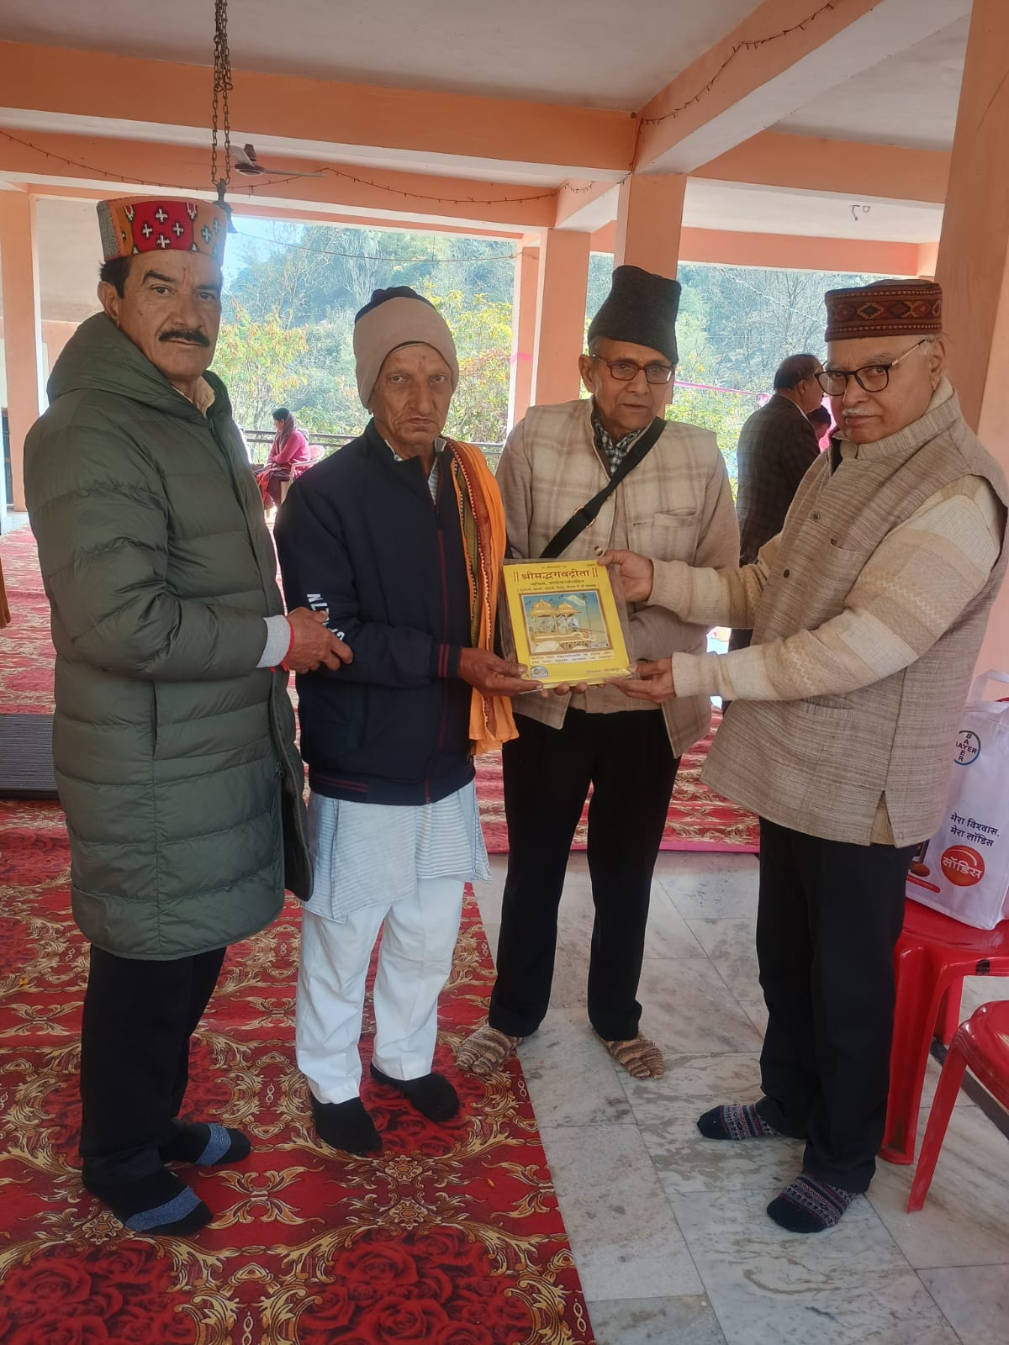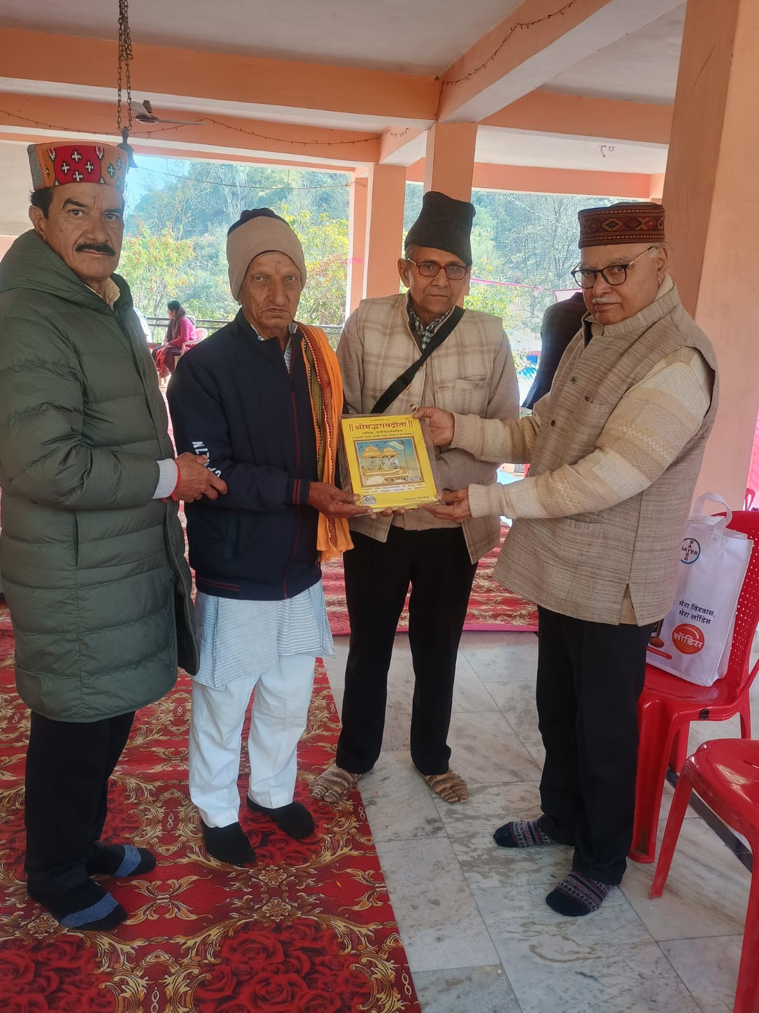

7. Flood Relief and Assistance to Disaster-Affected Families
Period: During the year 2023-24
During the year 2023–24, several districts of Himachal Pradesh, including Mandi, Kullu, Kangra, Hamirpur and Shimla, were severely affected by heavy rainfall and flooding, causing widespread disruption and hardship for many families. The natural calamity resulted in damage to homes, loss of belongings and serious difficulties in meeting immediate daily needs. Recognizing the urgency of the situation and the humanitarian need arising from the disaster, the trust responded promptly by extending relief and assistance to affected and needy families.
As part of its disaster response initiative, the trust reached out to vulnerable families impacted by the floods and provided timely support in the form of financial assistance and essential relief. The initiative was undertaken with the objective of helping families cope with immediate challenges and providing support during a period of uncertainty and distress. The trust made dedicated efforts to ensure that assistance reached those who were most affected and in genuine need of relief.
A total financial assistance of ₹5,35,000 was distributed among nearly 20 disaster-affected and needy families across the affected districts. This support was aimed at helping families recover from losses caused by flooding and assisting them in managing urgent requirements such as household essentials, temporary relief and other immediate necessities. The assistance provided served as a meaningful source of support during a difficult time and reflected the spirit of compassion and solidarity with the affected communities.
The relief initiative also highlighted the importance of standing together during times of crisis and supporting communities facing unexpected hardship. Through timely humanitarian intervention, the trust reaffirmed its commitment to serving society with care, responsibility and compassion. The programme reflected the values of social service and community support and strengthened the trust’s role in responding to emergencies and extending assistance where it is most needed.
The flood relief effort was a significant humanitarian initiative during the year and demonstrated the trust’s continued dedication towards disaster response, public welfare and service to vulnerable communities. The initiative concluded with appreciation for all those who contributed directly and indirectly in supporting the affected families and helping provide relief during a challenging period.

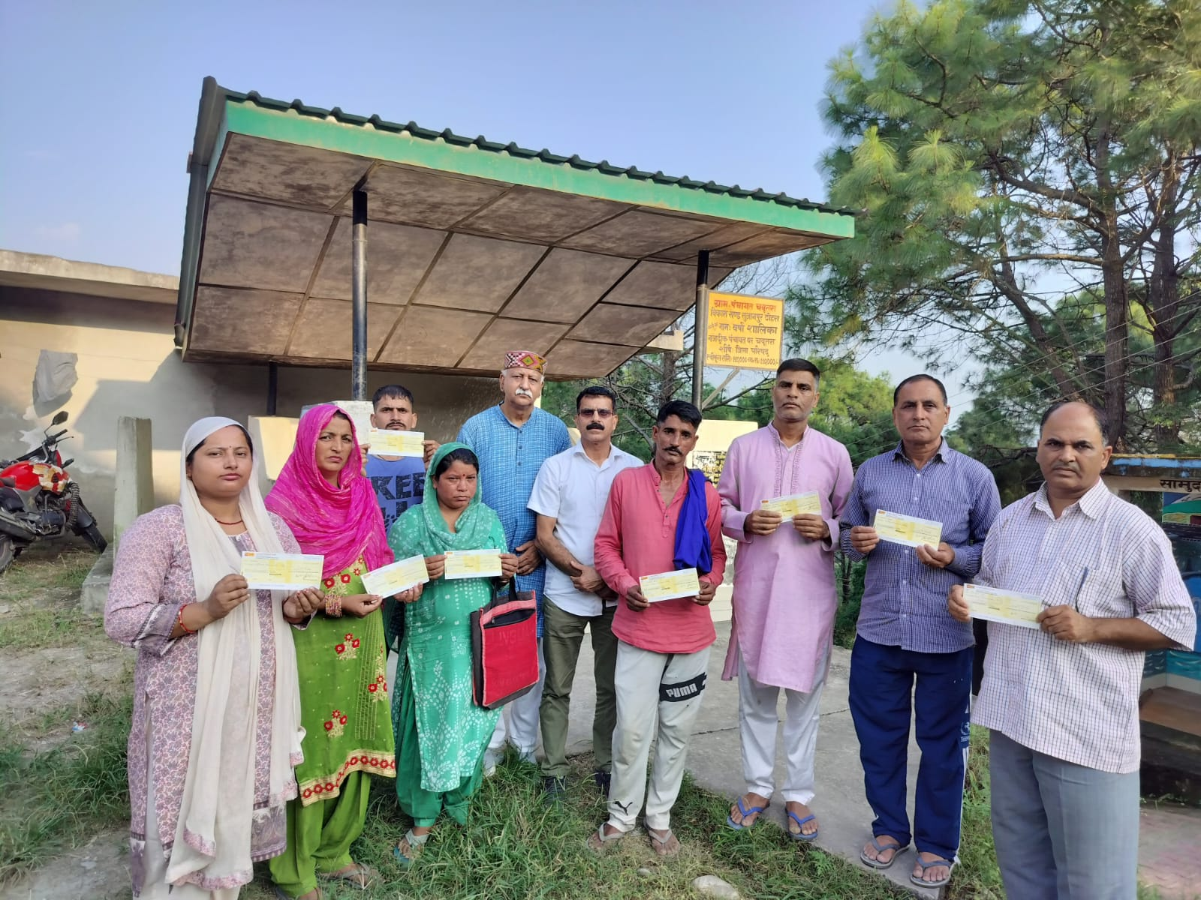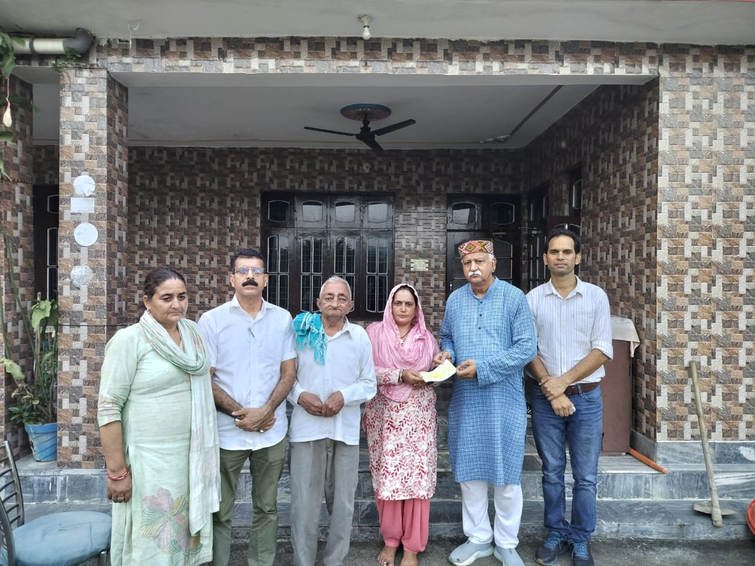

बाढ़ प्रभावित सहायता राशि (सूची)
क्र.सं. | नाम व पता | फोन नं. | चेक नं. | राशि (₹) | दिनांक
1 | अजय शर्मा S/o श्री अमर नाथ शर्मा, गांव टिपरी, डा० शेषण, तह० भुंतर, जिला कुल्लू (हि.प्र.) | 8215484968 | — | 25,000  25,000 | 11-09-2023  11-09-2023
2 | शिव राज S/o श्री जय राज, गांव मझाणा, डा० भूला, तह० सैंज, जिला कुल्लू (हि.प्र.) | 809147318 | — | 1,00,000 | 11-09-2023
3 | चमन लाल S/o श्री देवी रूप जी, गांव जूट, डा० सुग्गा, तह० सुग्गा, जिला मंडी (हि.प्र.) | 94185 83713 | — | 30,000 | 20-09-2023
4 | सुरेश कुमार S/o श्री हरी राम, गांव टिंडी, तह० उदयपुर, जिला लाहौल-स्पीति (हि.प्र.) | — | — | 25,000 | 13-10-2023
5 | रजनी सिंह S/o श्री धनश्याम सिंह जी, गांव व डा० बाली चौकी, जिला कुल्लू (हि.प्र.) | 94185 76664 | — | 1,00,000 | 23-11-2023
6 | मधु त्रिवेदी #1715, त्रिवेदी भवन, बावली गली, कांगड़ा (हि.प्र.) | — | — | 50,000 | 28-11-2023
7 | विमला देवी पत्नी योग राज शर्मा जी, गांव टिपरी, डा० शेषण, तह० भुंतर, जिला कुल्लू (हि.प्र.) | 82191 82479 | — | 25,000  25,000 | 01-12-2023  05-12-2023
8 | ओम प्रकाश शर्मा, गांव नागी मारी, डा० बनोगी, तह० बंजार, जिला कुल्लू (हि.प्र.) | 70183 79027 | — | 30,000 | 01-12-2023
9 | राकेश शर्मा S/o श्री मोहन लाल, गांव व डा० शाकरा, तह० करसोग, जिला मंडी (हि.प्र.) | — | 17509 | 50,000 | 30-03-2024
10 | रोहित कुमार S/o श्री ठाकुर दास, गांव व डा० चकोर, तह० ठियोग, जिला शिमला (हि.प्र.) | — | — | 50,000 | 30-03-2024
कुल राशि: ₹5,35,000/-

8. Plantation Drive – Tipper
During the year, Thakur Ram Singh Smriti Nyas organized a Plantation Drive at Tipper, District Hamirpur, Himachal Pradesh, as part of its commitment toward environmental awareness and ecological conservation. The programme was undertaken with the objective of promoting green cover, preserving biodiversity and encouraging community participation in environmental sustainability.
As part of the drive, around 1,000 saplings of different herbal and medicinal varieties were planted in and around the Tipper area. The plantation included a wide range of medicinal and herbal plants selected for their environmental value as well as their traditional importance in health and wellness. The initiative aimed to support long-term ecological balance while also promoting awareness regarding the importance of herbal and medicinal plants in everyday life.
The programme witnessed active participation from trust members, volunteers and local residents, who joined together in planting and caring for the saplings. The activity created awareness about environmental protection and encouraged community members to take responsibility for conserving natural resources and maintaining a cleaner, greener environment.
Along with the plantation activity, emphasis was also placed on the importance of preserving native plant species, promoting sustainable environmental practices and creating awareness about the role of medicinal plants in traditional knowledge and rural ecosystems.
The successful organization of the Plantation Drive at Tipper reflected the trust’s continued dedication toward environmental conservation, sustainable development and community participation. The initiative contributed meaningfully toward increasing green cover in the area while encouraging long-term environmental responsibility and awareness among local residents.
